Chester Moody Summitt (1931-2009)

Chester Moody SUMMITT was my dad. Dad, as with all of us, was a product of his time and of his environment. He was born on September 9, 1931, in Cardwell, Missouri. His father, Chester, was 44 and his mother, Katie, was 40. Dad was the second youngest of nine siblings. The same year that dad was born unemployment doubled to 16.3 percent. The Empire State Building opened in New York City. Al Capone was convicted on tax fraud charges. The small community of Las Vegas, Nevada decided to make gambling legal. It was also the year the Japanese invaded Manchuria which was the beginning of what would become World War II. The average cost of a new car was six hundred forty dollars. The average cost of a new house was under seven thousand dollars while the average rental of a house was eighteen dollars per month. Average wages per year were under nineteen hundred dollars. Gas cost ten cents per gallon, a loaf of bread was eight cents, and a pound of hamburger meat was eleven cents.
Agatha Christie’s Peril at End House and Aldous Huxley’s Brave New World were published in 1932. Ford released the Model Y and Koln that year in Europe. Adolf Hitler ran for president of Germany, starvation was a national tragedy in the Ukraine, and China and Japan fought a short-lived war over the city of Shanghai. Johnny Cash and Tiny Tim were born that year also. Amelia Earhart became the first woman to fly solo across the Atlantic Ocean and Bonny and Clyde ran rampant over the Midwest United States.
In 1933, Franklin D. Roosevelt proposed the “New Deal” in response to the Great Depression. Chicago Mayor Anton Cermak was killed by Giuseppe Zangara, an anti-capitalist Italian naturalized U. S. citizen, during an attempted assassination of the president-elect seventeen days before Roosevelt’s inauguration. The year also saw the passage of the 20th Amendment to the U. S. Constitution which set the beginning and ending of the terms of the elected federal offices, the 21st Amendment which ended Prohibition, and the Great Depression began. Elsewhere, Adolph Hitler became first Chancellor of Germany in January and then dictator in March, the USS Ranger becomes the first ever built US Navy aircraft carrier, and Machine Gun Kelly is captured by what later became the FBI.
On Aug 23, 1934, when Moody, as Dad came to be known, was two years old, his younger sister, Alice Lucretia, was born. Earlier that year, Germany signed a ten-year non-aggression pact with Poland and the Soviet Union signs a ten-year non-agreesion pact with Finland, John Dillinger was killed in Chicago, and the Dust Bowl had begun brought on by poor farming methods, heat waves, and severe drought, among other causes.
The following year the F. B. I. was established with J. Edgar Hoover as director, Huey Long was assassinated by Carl Weiss, Persia was renamed Iran, Mussolini’s Italian army invades Ethiopia, and Social Security became law.
Alice Lucretia died on February 9, 1935, in Cardwell, Missouri, when Dad was 3 years old. According to her death certificate, as shown below, Alice died around four in the morning on the ninth. Primary cause of death is listed as bronchopneumonia with other contributing causes listed as encephalitus.
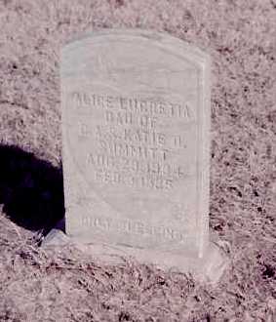Photograph 1: Headstone of Alice Lucretia Summitt, Cardwell Cemetary
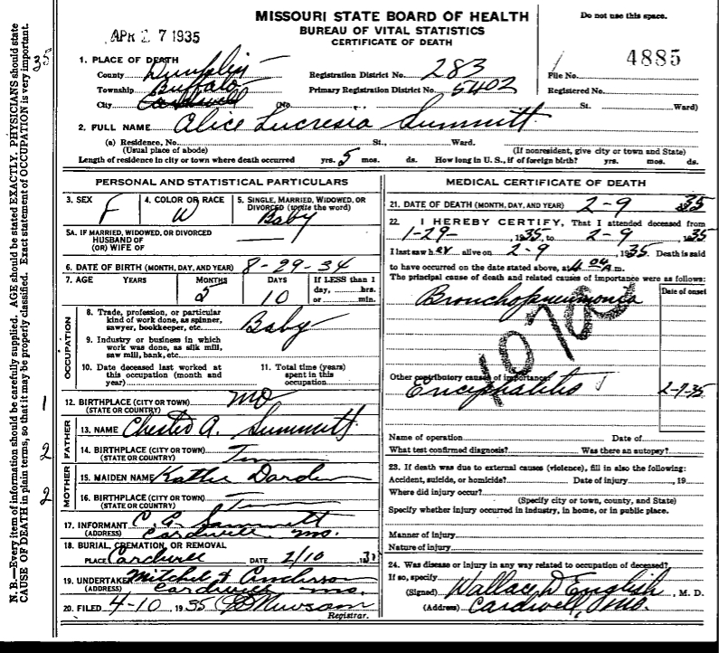
The death certificate is signed by Wallace D. English, M.D. of Cardwell, Missouri, and the undertakers are listed as Mitchell & Anderson of Cardwell, Missouri. The following obituary and thank you were published in the Dunklin Democrat.
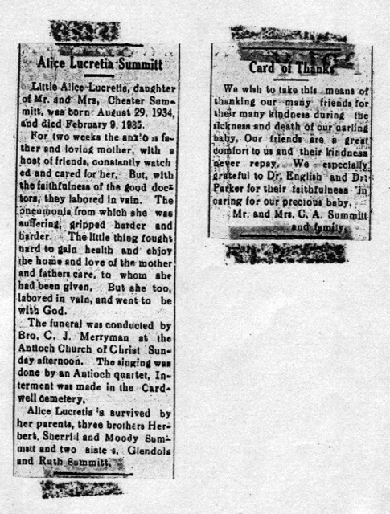
The year 1936 saw Roosevelt elected to his second term. Unemployment in the US drops to about fifteen percent. In England, King George V dies and Prince Edward succeeds him only to abdicate later in the year and is succeeded by George VI. A coup attempt in Japan fails and nineteen of the conspirators are executed. Arabs in Palestine revolt against British colonialism and increased Jewish immigration. Nine Jews in Jaffa are killed as Jewish homes are burned, shops looted, and orchards destroyed. More than 140 Muslims are killed by British soldiers during the rebellion. Using mustard gas, Italian forces take Ethiopia and unite it with Ertrea and Italian Somaliland into what is now called Italian East Africa. The Summer Olympics are held in Berlin. The American Abraham Lincoln Brigade sails to Spain attempting to defend Spain’s leftist government.
The following year, 1937, thirty-five people died in the Hindenburg disaster, Germany and Italy allied with Franco and the Fascists in Spain, the United States Navy gunboat USS Panay was attacked by the Japanese while anchored in the Yangtze River outside of Nanjing, Amelia Earhart and navigator Fred Noonan disappear of New Guinea, Japanese troops took both Shanghai and Nanjing, the Golden Gate Bridge opened to pedestrian traffic in San Francisco, and Walt Disney’s Snow White and the Seven Dwarfs became a hit at theaters.
Dad told me a story one time about a flood that covered the entire area around Cardwell. He was only old enough to have a tricycle so I’m guessing the flood he was talking about must have been the Great Flood of the Ohio and Mississippi Rivers from January through February 1937. My grandfather, Chester Alba (known as Papa), owned a house that apparently sat on the highest point of ground in the area so, according to Dad, everyone took refuge at Papa’s house.
In 1938 Nazi Germany occupied Austria and later demands part of Czechoslovakia which European powers accept, Superman debuted in Action Comics, and Orson Welles scared the country with The War of the Worlds.”
The 1939 Chillán earthquake, the deadliest earthquake in Chilean history strikes Chillán, killing approximately 28,000 people, Nazi Germany annexes the rest of Czechoslovakia, Italy invades Albania, the Spanish Civil War ends with Franco and the fascists in power, a ship carrying almost a thousand Jewish refugees is denied permission to land in Florida and forced to return to Europe, Nazi Germany and the Soviet Union enter into a pact whereby Finland, Romania, and Poland are divided between them, Detective Comics #27 is released which introduces Batman, Hitler orders the systematic euthanasia of mentally ill and disabled people, Germany invades Poland and Great Britain and France declare war on Germany, and Roosevelt gave the first televised presidential speech at the 1939 New York World’s Fair.
Dad first shows up in the 1940 census in the household of his father, Chester Alby Summitt, in 1940 in Cardwell, Missouri. According to the census, C. Moodie was an 8 year-old, single white male at the time of the census. He is listed as being born in Missouri, living on a farm, enrolled in school, and the highest grade completed being first grade.
Illustration 1: 1940 Census, Cardwell, Missouri
Dad’s father, Chester A., my grandfather, was listed as being a fifty-three year old, married, white male, having been born in Tennessee. Moody’s mother, Kattie O., was listed as being a forty-nine year old, married, white female also born in Tennessee. The census lists three older siblings living at home in 1940. Those siblings included two older sisters, Glendola D., a twenty year-old single, white female, and Ruth, a fifteen year-old single white female, and one brother, W. Sherril, a twelve year-old single, white male. All the children are listed as also attending school and having been born in Missouri as was Dad.
The year 1940 saw the U. S. population reach over 132 million people and also saw the first peacetime draft in U. S. History with the Selective Service Act. The Alien Registration Act also became law as the country made it set criminal penalties for advocating the overthrow of the the government by force or violence, and required all non-citizen adult residents to register with the federal government. Roosevelt was elected to a record third term and Bugs Bunny, Tom and Jerry, and Woody Woodpecker made their debuts that year.
In 1941 the United States occupied Iceland to prevent a potential invasion by Nazi Germany. Nazi Germany attacked its ally up until the time,the Soviet Union. In the U. S. the average cost of a house was just over four thousand dollars and renting a house averaged thirty-two dollars a month. The average wage was seventeen hundred and fifty dollars per year. Bacon was fifty-nine cents per pound and the price of a new car was eight hundred and fifty dollars. Then on December 7, 1941, Japanese fighter planes attacked Pearl Harbor, Hawaii, at 7:55 am. This surprise attack on United States soil destroyed the U. S. Pacific Fleet docked at the base. The attack, which took the lives of 1,177 sailor and marines, as well as the loss or damage to twenty-one naval ships, and a total of over 2,400 American lives, led to the entry of American troops into World War II. On December 8, 1941, the United States of America declared war on Japan, officially entering World War II. On December 11, 1941, the United States declares war on Germany and Italy, responding to their declaration of war against America. Dad was ten years old and lived in Cardwell, Missouri.
Several historical events took place in 1942. Probably the most appalling, from a human rights perspective, was Executive Order 9066. Roosevelt signed into law an act which confined over 110,000 Japanese Americans, 75,000 of which were American citizens, in detention camps around the country including two in Arkansas. In June of that year the Japanese fleet attacked the Midway Islands While the Japanese suffered a defeat at Midway, they were able to invade the Aleutian Islands which was the first invasion of American territory in 128 years. The Marines landed on Guadalcanal in the Solomon Islands in August becoming the first American offensive of World War II. A Japanese submarine surfaced off the California coast and shelled the coastline. In November the United States and Great Britain invaded North Africa.
February of 1943 saw the United States military suffer its first major defeat in North Africa at the Battle of Kasserine Pass in Tunisia. Race riots broke out in Detroit and Harlem causing forty deaths and seven hundred injuries. In July US forces invaded Sicily beginning the campaign for Axis-controlled Europe. Nine days later, Rome was bombed by Allied forces. In November, the Marines won the battle of Tarawa (also known as Bloody Betio).
June of 1944 brought the start of the battle for Guam in the Pacific as well as the invasion of Normandy, Operation Overlord, in Europe. German V2 rockets began hitting London and the airplane carrying Glenn Miller disappeared. November saw Roosevelt win a fourth term in office and in December, the U. S. Supreme court stated that it was alright to deprive citizens of their rights in time of war in the case of Korematsu vs the United States. The average cost of a house was about thirty-five hundred dollars while rent averaged about fifty dollars per month. Gas was fifteen cents a gallon and a loaf of bread was ten cents.
Dad never spoke too much about what happened locally during the war. He did tell me about how Papa helped him win a iron collection drive for the war effort. The prize was a month’s free admission to the Cardwell Movie Theater. Dad was never allowed to use the prize as Papa said movies were sinful. He did tell me about how, after he and Mom started dating, that she would go to the back exit and hold the door open so he could get in without Papa knowing but that would be a few years after the war.
February of 1945 saw Roosevelt, Churchill, and Stalin hold the Yalta Conference where they mapped out the world after the war. February also saw thirty thousand Marines land on Iwo Jima. March saw American troops cross into Germany. April saw in invasion of Okinawa and the death of President Roosevelt. Missouri politician Harry S. Truman suddenly became President. I don’t know what Dad thought of this but I know he was a southern democrat for much of his life so he was probably in favor of Truman. In May, Germany surrendered and in August the first and second atomic bombs where dropped and Japan surrendered. Dad turned 13 in September.
I don’t know when Dad started dating Mom. I have heard a story of Dad taking Mom home on a motorcycle and the road to her house was flooded so Dad had to carry Mom in his arms about a quarter of a mile through the flooded road because Mom had just had an appendectomy. This would have had to been around 1948 probably.
Mom was born Shirley Francis Frie on October 13, 1934 in Cardwell, Missouri, to Carman Lewis Frie and Iva Francis (Glasgow) Frie. Mom had two brothers; one older, Ray Lewis; and one younger, Larry Don. They lived about a mile Northeast of Cardwell on 55 acres that they owned. It was just down the dirt road from Carman’s parents house. I always knew them and Grandma and Papaw Kittens.
At some point during this period of time, Dad had an accident with a knife and sliced I think it was his hand pretty bad. He bled extensively, so bad that, according to him, they drove him to Memphis to get it treated. I remember him always talked about numbness in that hand later in life. It didn’t seem to hurt his guitar playing, however.
The 1946 saw war crime trials in Nuremberg and Tokyo, UNICEF was established, the first car phones were introduced by AT&T, bikinis went on sale in Paris, the United Nations held their first meeting, and the baby boomer years began. The average wages that year were around $2500, while a new house cost $5600.00 and gas went for fifteen cents a gallon. Eggs were sixty-four cents a dozen, chicken was forty-one cents a pound, and coffee was eighty-five cents for two pounds.
Aliens were said to have visited Roswell in 1947. India and Pakistan became independent nations. The CIA and IMF were established. The beginnings of the Cold War between East and West began. The United Nations voted in favor of the creation of an Independent Jewish State of Israel. The year saw the first instant camera, tubeless tire, transistor, the sound barrier was broken, and the first mobile phone. The price of a house went up to an average of $6,600.00. Average wages went up to $2,850.00. Postage stamps cost three cents and a loaf of bread was thirteen cents. A new car was $1300.00.
In 1948 the railway system in England was nationalized to form British Railways. Mahatma Gandi was assassinated in India. NASCAR was incorporated. The Berlin airlift began in April. The Marshall Plan, which authorized five billion dollars in aid for sixteen countries was signed by President Truman. Seventy-nine Jewish doctors, nurses, and medical students and one British soldier were massacred by Arabs near Jerusalem as part of the 1948 Arab-Israeli War. The U.S. Supreme Court rules that covenants prohibiting the sale of real estate to blacks and other minorities are legally unenforceable. The LP record album was introduced by Columbia Records. The National Health Service Acts create the national public health systems in the United Kingdom. The first hijacking of a commercial airplane takes place in July. President Truman signs the executive order that desegregates the US military. The Republic of South Korea is established. The first woman to serve in both the House and the Senate is elected. More Japanese are sentenced to death for their War Crimes.
In high school Dad played basketball, was a member of the Future Farmers of America, was in the glee club and chorus, was in the band, and was on the annual staff.
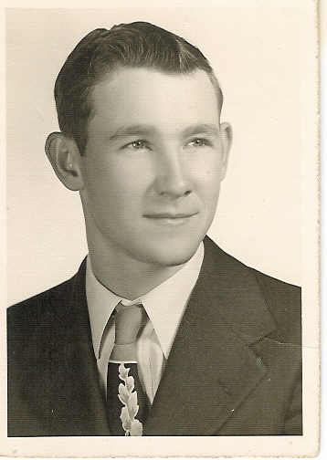
Dad graduated high school in 1950. Also in his senior class, as seen in the class picture on the next page, was his nephew Allison Summitt, his future brother-in-law Ray Lewis Frie, his future sister-in-law Bonnie Wallace, and Mom’s second husband Fred Queen. Dad’s older brother Sherrill, a teacher at Cardwell High School, was one of the senior class sponsors.
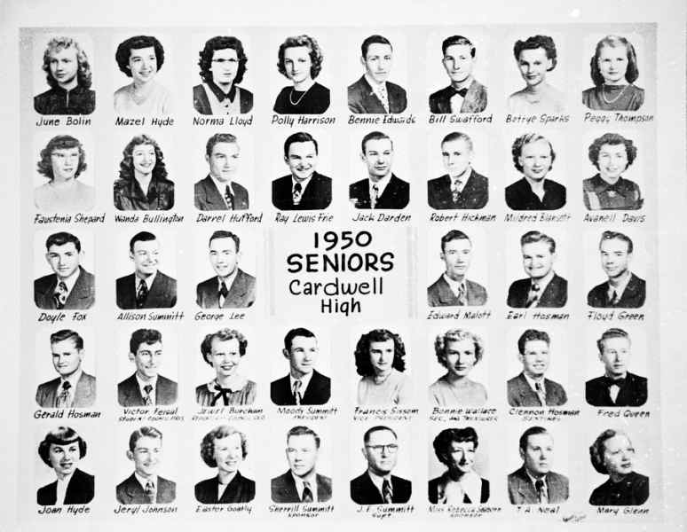
The year 1950 brought the discovery of the DNA Double Helix, the beginning of McCarthyism, the Montgomery Alabama bus boycott, the launch of Sputnik, and an uprising in Hungary. In June North Korean forces invaded South Korea and the Korean War began. In November there was an assassination attempt on President Truman. Mom and Dad got married in Arkansas on September 14, 1950. He had just turned 19 and she would be 15 for another month. They moved into a small house about two miles North of Cardwell and Dad worked on the farm.
The Korean War continued in 1951 and Korea was the site of several massacres of civilians by South Korean police and armed forces which took the lives of over 750 people said to be collaborators with North Korea. That year also saw the battle of Vihn Yen, a French victory in the French-Indochina War. Also happening that year one of the worst train disasters in American history occurred in New Jersey killing 85 people and injuring over five hundred. The 22nd Amendment to the Constitution of the United States was ratified which limited a President of the United States to two terms only. President Truman dismissed and relieved General Douglas MacArthur of overall command in Korea and MacArthur retires. The first surgical replacement of a human organ, the first scheduled transatlantic flights between New York and London, the invention of the first junction transistor, the publication of J. D. Salinger’s The Catcher in the Rye, the airing of the first episodes of CBS’s Search for Tomorrow and I Love Lucy, the start of direct-dial coast-to-coast telephone service in the United States, and the first nuclear reactor begins generating power all took place that year. Mom and Dad would live in the house North of Cardwell until Dad joined the Navy on December 1, 1951.
Dad ended up stationed at Kingsville Naval Air Station outside of Kingsville, Texas. Dad was a fireman and put out fires on the runways. The French-Indochina War was going on at the time and Dad said the Vietnamese pilots’ take-offs were great but their landings were terrible. He said he picked up his share of body parts on more than one occasion. This was while the French were fighting the Vietnamese Communists. The United States had some advisers in Indochina, and had had since 1945, but it was still France’s war and Vietnam didn’t exist yet.
Photograph 2: Dad's Navy Bootcamp Picture
The year 1952 saw the crowning of Queen Elizabeth in the United Kingdom, the allied occupation of Japan is formally ended, and former General Dwight Eisenhower (who detestede Senator Joe McCarthy) won the Republican nomination for president. That same year thirty-three year old Eva Peron of Argentina died of cancer, the first open-heart surgery was performed at the University of Minnesota, Great Britain plotted a coup in Iran, both Japan and China were refused membership in the United Nations, eleven former Czechoslovakian officials who happened to be Jews were sentenced to death by the Communist regime, a former US soldier underwent the transsexual operation in Denmark, and four thousand deaths occurred within two weeks of London’s five day “killer fog” with thousands more dying from reoccurring complications in the coming years.
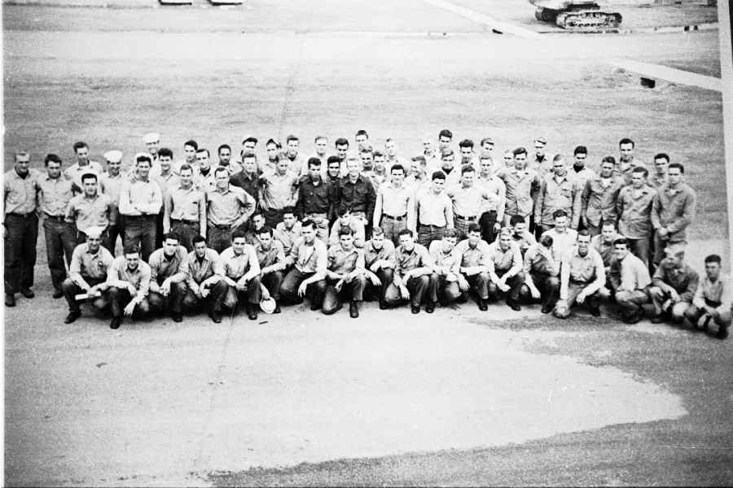
Mom joined Dad in Kingsville shortly after he was stationed there. Having both attended the Church of Christ, they looked for and found a local church there in Kingsville. There they met two couples that would become very important in their lives over the next few years. Papa Blackie and Grandma Dessie and Uncle Drayton and Aunt Dot, as I came to know them, became very dear friends for them, as well as Mom and Dad’s family away from home.
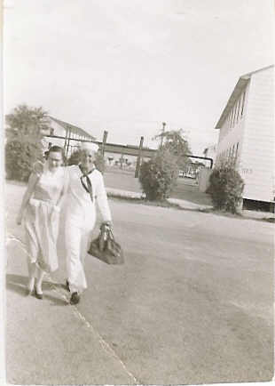Photograph 3: Mom and Dad on the Kingsville Naval Air Station
Arthur Miller’s “The Crucible” opened on Broadway and Eisenhower became President in 1953. A tidal surge in the North Sea killed over three hundred people in Britain and almost two thousand in the Netherlands that year, also. Joseph Stalin dies in Moscow and the crowds of mourners are so large and out of control that people are crushed to death. An atomic bomb was accidentally dropped in South Carolina but was not prepared for detonation. Greenland becomes its own nation, Julius and Ethel Rosenberg, accused and convicted of espionage and passing secrets to the Soviet Union, are executed here in the United States. The United Nations, China, and North Korea sign an armistice agreement but South Korea refuses to sign it. The CIA and British agents arrange a coups in Tehran as over two hundred people are killed. Nikita Khrushchev becomes First Secretary of the Communist Party in the Soviet Union. Laos and Cambodia are granted independence from French rule. US scientists identify the polio virus for the first time. Toward the end of the year, French paratroopers take Dien Bien Phu, a point blocking the main invasion route between Laos and Vietnam.
Dad’s mother, Katie Okalona Darden Summitt, passed away in Memphis, Tennessee on October 21, 1953. She was 63. She was born September 11, 1890 in Tennessee. Her parents were James K. Darden and Nancy Tucker Darden. She had married my grandfather in Cardwell on February 29, 1908.
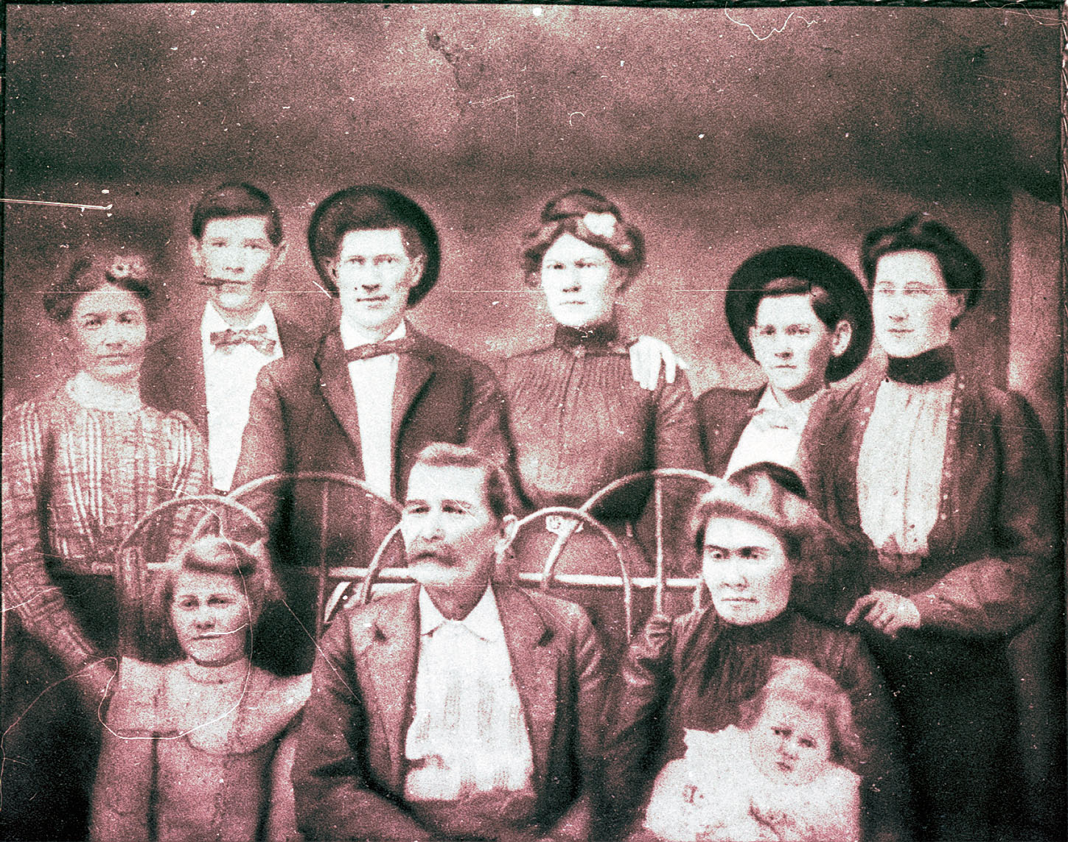Photograph 4: Katie Okalona Darden is on the lower left sitting.
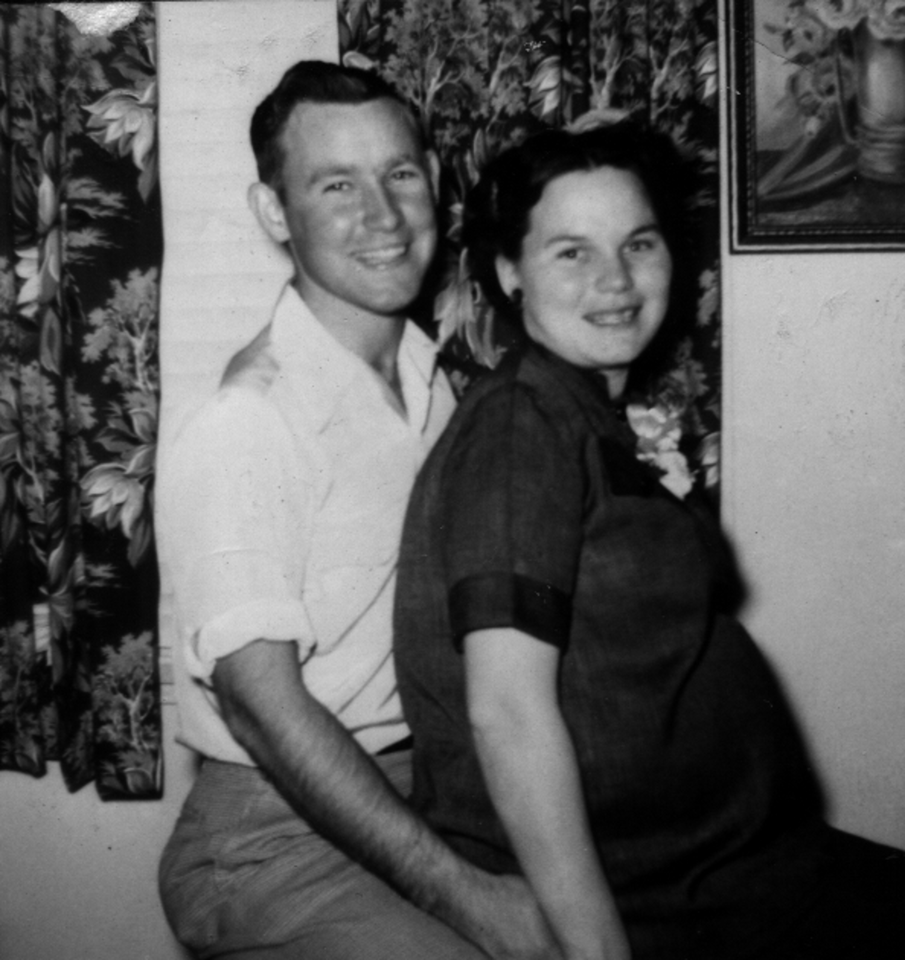
Shortly after Mama Katie’s death Mom discovered she was pregnant. I remember her telling me that she was so big she thought that I was putting my feet on her spine and pushing out forward with my hands.
The 1954 saw the merger of Hudson Motor Car company with Nash-Kelvinator Corporation forming the American Motors Corporation. The first US nuclear submarine, the USS Nautilus, is launched while Eisenhower warns against United States intervention in Vietnam. The first mass inoculation of children against polio with the Salk vaccine takes place. The first color television sets using the NTSC standard are offered for sale to the general public. Members of the Puerto Rican independence movement attack the United States Capital building injuring five US Representatives. CBS producer, Fred Friendly, hosts the “See It Now” episode on McCarthyism. The Battle of Dien Bien Phu begins in March and ends in May with a defeat for the French. The United States Air Force Academy is established in Colorado. The US Supreme Court hands down a unanimous decision in “Brown v. Board of Education of Topeka, Kansas.” President Eisenhower signed a law that placed the words “under God” in the US Pledge of Allegiance. The Geneva Conference partitioned Vietnam into North and South Vietnam. The first issue of “Sports Illustrated” was published. The Communist Control Act went into effect which outlawed the American Communist Party. The Toya Maru sank during a typhoon off the Japanese coast killing almost twelve hundred people. Communists took over North Vietnam and Eisenhower pledged US support to South Vietnam. The first Godzilla film was released. A woman in Alabama was killed when a meteorite crashes through a roof while she is taking a nap. Senator Joseph McCarthy was censured by the Senate for “conduct that tends to bring the Senate into dishonor and disrepute.” Also, the first Burger King opened.
On April 7, 1954, I was born there in Kingsville, Texas. They named me Paul Moody Summitt. Mom said that she carried me for over ten months and that I was born with a head of hair and a mouth full of teeth. Dad was 22 and Mom was 19. Papa and Papaw and Granny and Mom’s brother, my Uncle Larry, all came to Kingsville to see me.
Photograph 5: Papa, Dad, and me.
Photograph 6: Uncle Larry, Papaw, Granny, and me.

Dad’s enlistment was over November 30, 1955. He entered Arkansas State College and studied agriculture. Then, some time after 1956, we moved to Columbia, Missouri where he started studying Agriculture at the University of Missouri.
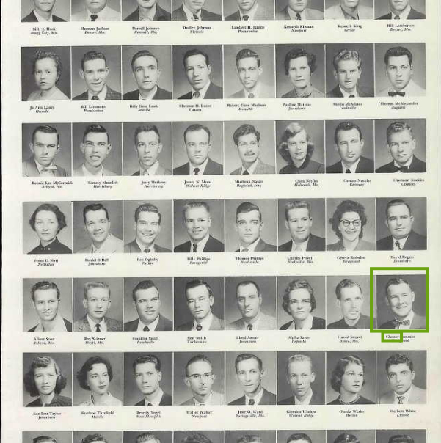Photograph 7: Dad at Arkansas State College 1956
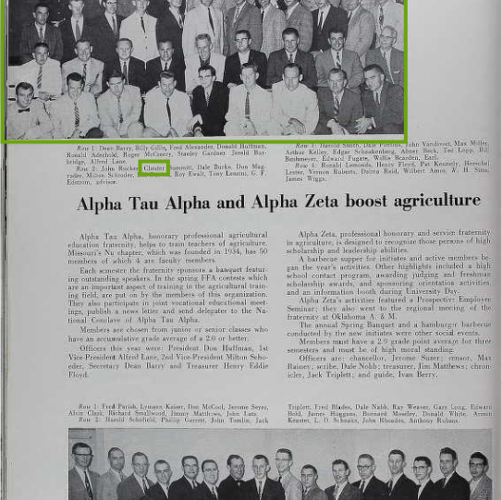Photograph 8: Dad at University of Missouri 1959
The year 1957 started off badly as a Douglas DC-7B being delivered to Continental Airlines collided midair with an Air Force Northrop F-89 Scorpion over Pacolma, California injuring over seventy-five junior high school students on the ground and killing all four crew members on the DC-7B, the pilot of the F-89, and three junior high school boys. Ngo Dinh Diem of South Vietnam survived an assasination attempt. The Suez crisis ends and the Suex Canal is reopened by Egypt. The State of Georgia petitioned the U.S. Congress to declared the 14th (which addressed citizenship and the rightsof citizens) and 15th (which guaranteed that the right to vote couldnot be denied based on “race, color, or previous condition of servitude”) Amendments to the Constitution null and void. Almost a thousand people were killed in a mudslide near Nagasaki, Japan. Ford Motor Company introduced the Edsel. The 101st Airborne Division is sent by President Eisenhower to enforce desegregation. “In God we trust” first appeared on US paper currency. Also occurring that year, The Soviet Union put the first animal into orbit, Leave it to Beaver premiered on CBS, the first ‘recognized’ US casualties in Vietnam occur, and President Eisenhower had to publicly apologize to the finance minister of Ghana after he was refused service in a Delaware restaurant.
In 1958, Dad and Mom showed up in the Columbia, Missouri city directory. We lived in the married housing Quonset huts that were located where the MU football stadium and Hearnes Center is now. Dad took classes in Switzler Hall which was the School of Agriculture at that time. Mom got a job at what was then the Student Health Center and is now Noyes Hall.
Photograph 9: 1958: Dad and me, University of Missouri, Columbia, Missouri
As the country entered a recession and unemployment increased to over 7%, the price of gas rose to twenty-five cents a gallon while a year’s wages on the average was $4600. The price of a new house was then almost thirteen thousand dollars and the average monthly rent for a house was $92 per month. It was also the year the microchip was first developed, the US sent its first satellite into orbit from Cape Canaveral, and seven Manchester United players died in the Munich air disaster.
After Dad graduated, he went to work for DeKalb for a while. In 1959 we moved to New Madrid, Missouri and I started Kindergarten. The year 1959 saw Alaska admitted as the 49th state of the Union and later in the year Hawaii became the 50th. The United States recognized the new Cuban government of Fidel Castro that year also. This was also the year that the “unsinkable” MS Hans Hedtoff struck an iceberg on her very first voyage and killed all 95 people aboard. Bonanza premiered on NBC and was the first regularly scheduled program presented in color. Buddy Holly, Richie Valens, and J. P. “The Big Bopper” Richardson died in a plane crash in February. Both the US and the Soviet Union both successfully tested intercontinental ballistic missiles that year also, the Barbie doll was debuted at the American International Toy Fair, and the 1st Grammy Awards were held. The US Postal service attempted to delivery the mail via missile and the first US submarine to carry ballistic missiles was launched. A typhoon hit Japan killing over 4500 people and leaving 1.6 million homeless. The Twilight Zone premiered on CBS, the Quiz Show scandals are taken up by a Congressional committee, and the payola scandal hits American radio. Ford Motors quietly announced the discontinuation of the Edsel.
Dad moved us next moved to Poplar Bluff, Missouri when, I believe, Dad went to work for the Missouri Extension Service as a conservation agent. On December 31, 1959, my little brother, Bruce Allen Summitt, was born. I remember Mom telling me that she had wanted his middle name to be spelled Alan but whoever was writing the information down on the official documents thought her maiden name must have been Allen and that’s why it’s spelled that way. According to her, Dad was at a New Year’s Eve party when Bruce was born. After their divorce there were many stories she told about his alleged infidelities.
Politically, Dad was a typical southern Democrat during this point in time as were most people in the boot heel of Missouri. The Democratic party in the south hadn’t changed much since the Civil War. Most southern Democrats, while perhaps not overtly, were racist. I know Dad voted for Nixon in 1960, despite being a Southern Democrat, because Kennedy was a Catholic and I remember Dad talking about how Kennedy would be a puppet for the Pope. I think that was the beginning of the Southern Democrat move to the Republican Party that continued for the next forty years.
Domino’s Pizza was founded in 1960 and Dr. Seuss was extremely popular. Cassius Clay (who later changed his name to Muhammad Ali after converting to Islam while in prison for draft evasion) won the light-heavyweight gold medal at the 1960 Summer Olympics. Later in the year he would win his first professional fight. Frank Sinatra founded Reprise Records. Four black students sat at a segregated lunch counter in Woolworth’s in Greensboro, North Carolina, sparking the Greensboro sit-ins. France set off its first atomic bomb becoming the world’s fourth nuclear power. In South Africa, police began shooting into a crowd creating the Sharpeville Massacre. The US U-2 Spy plane was shot down over the Soviet Union. The Valdiva earthquake in Chile became the most powerful earthquake on record with a 9.5 on the Richter scale. Alfred Hitchcock’s Psycho and Stanley Kubrick’s Spartacus were released and Harper Lee’s To Kill A Mockingbird was published. The first televised Presidential Debate occurred featuring Richard Nixon and John F. Kennedy. Kennedy would go on to win the presidency. Edward R. Murrow’s last documentary, Harvest of Shame, aired on CBS showing the plight of the American migrant worker.
The year 1961 began with a core explosion and meltdown in a government-run nuclear reactor near Idaho Falls,Idaho, that killed three people. A B-52 carrying two hydrogen bombs exploded over Goldsboro, North Carolina and the uranium core from one of the weapons was never found. President Kennedy delivered the first live Presidential televised news conference. A Soviet submarine sank with all hands lost. The United States sent a chimpanzee into space as part of Project Mercury. The Peace Corps was established. Residents of Washington, D.C. were allowed to vote in presidential elections with the passage of the 23rd Amendment. The Soviet Union put Yuri Gararin, the first human being into space aboard the Vostok. Financed and trained by the CIA, a group of Cuban exiles invaded Cuba but failed to oust Fidel Castro. The Soviet Union launched its first nuclear submarine equipped with ballistic missiles. Alan Shepard became the first American and second human to travel to space. Newton N. Minow, chairman of the Federal Communication Commission, called broadcasting a vast wasteland. Martial law is declared in Alabama in an attempt to restore order after riots break out. Freedom Riders were arrested in Jackson, Mississippi after getting off their bus for “disturbing the peace.” President Kennedy announced to Congress that the country should put a man on the moon before the end of the decade. The Berlin Crisis began. Gus Grissom becomes the second American in space. Agent Orange was first used in Vietnam. The Dick Van Dyke Show premiered on CBS. President Kennedy sent 18,000 military advisors to South Vietnam.
In October of 1962 during the Cuban Missile Crisis, Dad said that the Navy had contacted him and offered him a post as a warrant officer if he’d join back up. Apparently, as the crisis was short-lived, the Navy didn’t maintain their interest and Dad didn’t join back up. The U. S. Navy established the Seals during 1962. Pope John XXIII excommunicated Fidel Castro. An avalanche in Peru killed four thousand people. John Glenn became the first American to orbit the planet. Bob Dylan released his first album. Walter became the anchor of the CBS Evening News. Scott Carpenter became the second American to orbit the earth. The first Walmart opened in Rogers, Arkansas. Nelson Mandela was jailed in South Africa and would not be released until 1990. James Meredith became the first African-American to enter the University of Mississippi. Wally Schirra became the third American to orbit the earth.
We moved to De Soto, Missouri around 1963. Dad was still with the extension service and was the sponsor for the local 4-H Club. I can remember being a member and attending meetings with him. On at least two occasions I remember going to a week long summer camp at Lake Wappapelo and Dad was one of the counselors there. That year the US Congress passed the Equal Pay Act and the Clean Air Act, Alfred Hitchcock’s The Birds was released, the Beatles released “Please Please Me,” Kellog’s Froot Loops were first introduced, the USS Thresher, carrying 16 officers, 96 enlisted, and 17 civilian technicians, was lost during deep-divings tests, the Battle of Ap Bac resulted in the first major combat victory for the Viet Cong against regular South Vietnamese and American forces, Alabama Governor George Wallace stood in the door of the Foster Auditorium at the University of Alabama to prevent two African-American students from entering, Martin Luther King, Jr. delivered his “I Have a Dream” speech, four African-American little girls at Sunday class and two people in the street were killed when a bomb was thrown from a passing car into the 16th Street Baptist Church in Birmingham, Alabama, President Kennedy ratified the Limited Nuclear Test Ban Treaty and ordered the withdrawl of one thousand military personnel from Vietnam, and the president of South Vietnam is assassinated during a CIA-backed South Vietnamese military coup d’etat. On November 23, 1963, John F. Kennedy was assassinated. I remember being at school and all of us were taken out to the playground as the flag was lowered to half mast.
I remember we always tried to go somewhere on summer vacation. I believe what I refer to as “the vacation from Hell” occurred in 1964. That year Dad, Mom, Papaw (Carman Frie), Granny (Iva Glasgow Frie), my brother Bruce, and myself, all crammed into our station wagon and headed west along Route 66. The entire trip took two weeks. We stopped at the Grand Canyon, the petrified forest, Salt Lake City, Yellowstone, Custer’s Last Stand, the Black Hills, and probably several other locations during those two weeks. I remember on night camping at the coldest place in the country and the next morning being at Needles which was the hottest place in the country. My grandfather taught me to catch a trout with my bare hands in the Snake River. My grandmother was patted on the back by a Black Bear while she was asleep and I was chased by a Grizzly at Yellowstone.
President Lyndon Johnson declared the “War on Poverty” and announced the goals for his Great Society social reforms were to “end poverty and racial injustice in America” in the year 1964. Later in the year he would sign the Civil Rights Act, meant to prohibit segregation in public places, into law. The 24th Amendment to the US Constitution was ratified prohibiting the use of poll taxes in national elections. An unarmed US Air Force jet on a training mission was shot down over East Germany by a Soviet MiG-19 fighter. The Beatles had their first hit in America with “I Want To Hold Your Hand” and also made their first appearance on The Ed Sullivan Show. Jack Ruby was found guilty of killing Lee Harvey Oswald, the assumed assassin of John F. Kennedy. Sidney Poitier became the first African-American male to win the Academy Aware for Best Actor for Lilies of the Field. Three civil rights workers were murdered in Mississippi. Five thousand more military advisers are sent to Vietnam bringing the total American forces to 21,000. The Gulf of Tonkin incident occurs resulting in the first bombing of North Vietnam in retaliation for the alleged gunboat attack on US destroyers and Congress giving President Johnson broad war powers to deal with North Vietnam. China detonates it first nuclear weapon. The last executions take place in the United Kingdom and in Western Australia.
In 1965, Mom and Granny decided to take Bruce and myself on vacation without Pa-paw and Dad. Pa-paw said he couldn’t be away from his animals on the farm that long again and I don’t think Mom wanted Dad to go. We visited the meteor crater in Arizona, Disneyland, and the Petrified Forest. I remember while we were at the Petrified Forest Granny was taking a picture of Mom, Bruce, and I. I saw a lizard and pointed it out and Bruce crawled up Mom’s leg trying to get away from it. Watching him climb my mother like a tree has always been one of my favorite memories.
The year 1965 saw Fender guitars sold to CBS. Hullabaloo premiered on NBC-TV. Outer Limits aired for the last time on ABC-TV. Winston Churchill, former prime minister of Great Britain died at the age of 90. Cassius Clay converted to Muslim and adopted the name Muhammad Ali during 1965. Another coup occurred in South Vietnam and the US began regular bombing of North Vietnam. Nat King Cole died at the age of 49. Malcolm X was assassinated at the age of 39. State troopers and black protesters clashed in Selma, Alabama. US Marines landed in South Vietnam. Jeff Beck replaced Eric Clapton in the Yardbirds. On April 11, forty tornadoes hit the Midwest killing 272 and injuring five thousand people. US Marines invaded the Dominican Republic, staying from April to October. India was hit by two cyclones in less than a month killing 35,000. The Supreme Court struck down a federal law that allowed the post office to intercept communist propaganda as unconstitutional. Sonny Liston was knocked out by Muhammad Ali in the heavyweight boxing title match. The first African-American graduates from the University of Alabama. The first two pilots of the television series Star Trek are made. Morley Safer sends first report from Vietnam suggesting the US is loosing. A fire in a Titan II silo in Searcy, Arkansas leaves 53 dead. The National Guard was called out to deal with race riots in Los Angeles. India invaded Pakistan. F-Troop, Lost in Space, and Get Smart premiered on ABC, CBS, and NBC respectively. KTWU TV channel 11 in Topeka, Kansas (PBS) began broadcasting. The Gateway Arch in St. Louis, Missouri was completed. The massive power failure in New England and Ontario, known as the New York Blackout occurred in November. A Charlie Brown Christmas first aired that year also.
Mom and Dad took my brother and I to a large number of different historical locations. Shiloh National Battlefield, the Parthenon in Nashville, Cape Kennedy, the Grand Canyon, Custer’s Last Stand, Yellowstone National Park, the Petrified Forest, Disneyland, and the Black Hills were just some of the trips we took over those years.
By 1966 we were in Bevier, Missouri. We didn’t stay there very long, although I remember playing little league baseball while there. That year a B-52 bomber collided with a KC-135 Stratotanker over Spain killing seven airmen and dropping three 70-kiloton nuclear bombs near the town of Palomares. The South Vietnamese army massacred 380 unarmed civilians at Go Dai. Sixteen people were killed and over one hundred million dollars in damages result from an F5 tornado that struck Topeka, Kansas. The Freedom of InformationThe purging of intellectuals becomes official policy in China. The last Beatles concert for paying fans and the first episodes of Star Trek aired. The Binh Tai, Dien Nien, and Phuoc Binh massacres allegedly perpetrated by South Korean Marines occurred in South Vietnam. One hundred forty four people, mostly children, we killed in Aberfan, Wales when a slag heap collapsed. The National Football League and the American Football League merged. The Greek ship Heraklion sinks during a storm in the Aegean Sea killing over 200 people.
A short time later, we moved to Macon, Missouri. Dad joined the Junior Jaycees there. I remember meeting Tex Ridder at the Jaycees Rodeo and remember Dad playing basketball against the RedHeads, an all redheaded female basketball team similar to the Globetrotters. One of them backed into Dad during the game and claimed Dad pinched her on the rear. Everyone laughed. Except Mom, of course.
Sometime around this Dad took us to Colorado for the summer. We lived in a tent in a national park while he attended graduate school. Mom really hated it. I, personally, loved it. I remember we went hiking one afternoon and got lost. After hearing a mountain lion scream, Dad found a way down the mountain in the dark in one third the time it took us to climb it during daylight.
We moved back to Poplar Bluff, Missouri in 1967. Dad was working for the Health Department at the time. I remember taking a course that he taught on preparing for a nuclear disaster. I also remember my brother being in pictures for a burn injury program slide presentation Dad prepared. In Vietnam, US troop levels rose to 475,000. Boxer Muhammad Ali was stripped of his world championship title for refusing to be inducted into the army. Israel went to war with Syria, Egypt, and Jordan for the six day war. American cities exploded with rioting and looting. Twiggy was the newest model of fashion. The Beatles released Sgt. Peppers Lonely Heart Club Band, and Americans listened to The Grateful Dead, Jefferson Airplane, and the Byrds. The Graduate and Bonnie and Clyde were showing in the theaters while The Fugitive and The Monkeys were on television and made in color. A new home cost on the average almost twice the average income of $7,300 per year at $14,250 while average monthly rent was $125. Gas was 33 cents per gallon, a new car was under $3000, and a movie ticket was $1.25. The minimum wage was increased to $1.40 an hour.
One Christmas while we lived there, Dad was putting up lights on the house. My brother, Bruce, and I were outside helping do what we could but mainly, I think, just wanting to be outside with Dad. Dad set the hammer he was using on the roof while he was working with something and the hammer slipped off. I watched as it fell in what seemed like slow motion until it hit Bruce on top of the head. I wasn’t able to say anything to warn him. I don’t remember it knocking Bruce down but I know it had to have hurt. Dad came climbing down quickly to check on him. I really don’t think Bruce ever forgave him.
Perhaps because of that burn injury slide presentation, Dad got a job in Louisville, Kentucky around 1968 and we moved there. I remember Dad found Summitts in the phone directory and wanted to meet them until he discovered that they were black. I remember him saying he knew they weren’t related to us. The year 1968 started off with the Tet Offensive in Vietnam surprising both US and South Korean forces and causing heavy casualties. The year also saw the Prague Spring in Czechoslovakia as communist rule liberalized for one week until the Soviet army invaded and occupied the country while the United States stood by and did nothing. Eighty-three US navy crew members of the USS Pueblo after the intelligence vessel was taken in what was claimed to be international waters. The My Lai massacre by US ground troops occurred in South Vietnam. Martin Luther King, Jr. was assassinated in Memphis and Robert F. Kennedy was assassinated in Los Angeles. Television showed the world the bloody clashes between police and demonstrators in Chicago at the Democratic Party convention. Gold and bronze wining US African-American athletes at the Summer Olympics in Mexico City, Mexico, bowed their heads and raised their black-gloved fists saluting the Black Power movement during the playing of The Star-spangled Banner. Republican Richard Nixon won the presidential election. Mom and Dad both voted for George Wallace.
We visited Cape Kennedy during the summer of 1969. Apollo 10 had just returned from the moon and we attended a parade in the astronauts’ honor. I remember swimming in the Atlantic Ocean on that trip. Later Neil Armstrong would be the first man to set foot on the moon. Jim Hendrix, Crosby, Stills, Nash, and young, and The Who were among musical artists who attracted over 350,000 people to a small farm in upstate New York called Woodstock. Hurricane Camille hit the Mississippi coast killing 248 people. Project Blue Book, the US Air Force investigation into UFOs was ended that year.
Sometime around that time frame, I remember us visiting Papa and Granny and Mom and Dad and her parents talking about the war. I remember Dad telling them that if I decided I wanted to go to Canada that he’d support my decision. I remember getting angry and telling them that I would die for my country. Youth is rather stupid at times.
The year 1970 began with 15,000 people dying in a 7.7 earthquake in China. The Chicago Seven were found not guilty of conspiring to incite the riots at the 1968 Democratic National Convention. A French submarine exploded underwater killing the entire crew. Captain Ernest Medina was charged with the My Lai war crimes and 14 other officers were charged with suppressing information about the incident. Israeli bombers struck a Egyptian school killing 46 children. Paul McCartney left the Beatles. An oxygen tank aboard Apollo 13 exploded causing damage and putting the crew in danger. A Soviet submarine sank in the Bay of Biscay with four nuclear torpedoes on board. Formal authorization for American combat troops to enter Cambodia was given by President Nixon. The Hard Hat Riot erupts on Wall Street between blue-collar construction workers and Vietnam War protesters. The female United States Army Generals are appointed by President Nixon. Charles Mason went on trial for the Sharon Tate murders. After 11 years, the Aswan Dam in Egypt is completed. An attempted assassination of Jordan’s King Hussein is attempted by Palestinian guerrillas. Jordan is invaded by Syria. The entire Wichita State University football team, administrator, and supporters are killed when their plane crashes in Colorado. PBS was founded. The Khmer Rouge takes power in Cambodia. The US Supreme Court votes 6 to 3 against hearing a case to allow Massachusetts to enforce its law granting residents the right to refuse military service in an undeclared war.
On March 10, 1970, Dad’s father, Chester Alba, passed away at the hospital in Memphis, Tennessee at the age of 83. Dad had flown back to Memphis from Louisville, Kentucky, where we were living at the time. Mom, Bruce, and I drove back a couple of days later. At the funeral, it was the first time I think I had ever seen my Dad cry.
By the summer of 1970, Dad had gotten a job in Jonesboro, Arkansas and we moved there. Dad ended up getting his grandmother’s family Bible. That was the beginning of my family history journey. The Bible was full of information concerning the parents, children, and family of Jonathan Summitt, my great great grandfather. Soon I was in touch with Paul Clayton Summitt, my second cousin, whom I would come to view as my family history mentor.
Dad joined the Elks Lodge in Jonesboro shortly after we moved there. Mom got a job at the Elks as secretary and I got a job there as busboy. Jonesboro is in Craighead county and Craighead was a dry county. In other words, no liqueur was supposed to be sold. So what the good upper class religious people of Craighead county did was establish private clubs like the Elks (which was also all white at that time) so they could drink. Saturday nights at the Elks and Sunday mornings at church. That was Jonesboro.
The year 1971 saw the end of cigarette advertising on television in America. All in the Family premiered on CBS. Charles Manson was found guilty and sentenced to death for the 1969 Sharon Tate murders. The real Frank Serpico, a NY city police officer, is shot during a drug bust, allegedly by other police officers, but survives to testify against police corruption. Backed by US air and artillery support, South Vietnamese troops invaded Laos. The war in Bangladesh for independence from Pakistan began. Lt. William Calley was convicted of premeditated murder for the My Lai massacre. Memorial Day is moved from May 30th to the last Monday in May. The US Government forcibly removed Native Americans from Alcatraz after nineteen months of occupation. The crew of the Soviet Soyuz 11 spacecraft died when their air supply escapes through an empty valve. The voting age was dropped from 21 to 18 after the passing of the 26th Amendment. The first lunar rover explored the moon. Australia and New Zealand withdrew their troops from South Vietnam. Walt Disney World opened in Florida. Duane Allman was killed in a motorcycle accident in Macon, Georgia. Indian troops defeated the Pakistani army in the Battle of Garibpur leading to the Indo-Pakistani War of 1971. The Montreuz Casino in Switzerland is set ablaze during a Frank Zappa concert leading to Deep Purple’s song Smoke on the Water.
I graduated high school in 1972 and that summer I moved to Austin, Texas to attend the University of Texas on a Navy scholarship. Eastern Pakistan became Bangladesh that year. A World War II Japanese soldier was found in the jungles of Guam where he had been hiding since the end of the war. British Paratoopers opened fire on and killed fourteen unarmed marchers in Northern Ireland. The deadliest snowstorm in history killed 4,000 people in Iran. One hundred twenty-five people are killed when a dam burst in West Virginia. The Equal Rights Amendment was sent to the states for ratification. B-52s began bombing North Vietnam for the first time since 1967 and the major ports of North Vietnam are mined. Okinawa returned to Japanese control. The first Popeye's Restaurant opened in Louisiana. The Watergate Scandal broke in the news. The first Gay Pride march took place in London, England. The last US ground combat unit left Vietnam. The Munich massacre takes place at the Summer Olympics. A race riot took place onboard the USS Kitty Hawk off the coast of Vietnam. HBO launched its programming on cable television. The last Apollo mission to the moon took place. Atari released the Pong game. A 6.5 earthquake struck Managua, Nicaragua killing more that 10,000 people. Sixteen survivors of the Andes Mountain air crash are rescue after 73 days, having survived by cannibalism.
The year 1973 saw me still at UT-Austin. Things had grown tense between Mom and Dad. Dad went to work in Malden, Missouri. The US ended its involvement in the Vietnam War after signing the Paris Peace Accords. Inflation in the US was running at 6.16% partly because of OPEC restricting the flow of oil that supported Israel during the You Kippur War. Roe v Wade was decided making abortion a constitutional right and the Watergate hearings began in the US Senate. American Graffiti hit the theaters. The occupation of Wounded Knee in South Dakota by 200 Oglala Native Americans and members of the American Indian Movement began. Vice President Agnew resigned. The average cost of a new home was $32,000 while monthly rent was $175. Gas was forty cents a gallon and new cars were under $4,000.
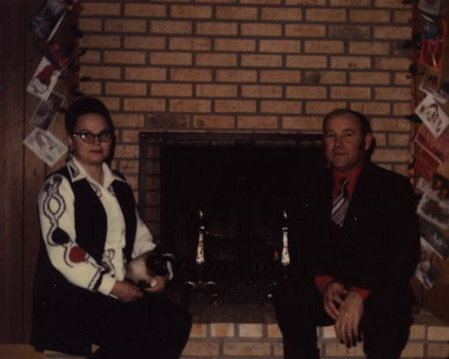Photograph 10: Mom and Dad Christmas 1973
I returned home at the end of my fall sophomore year from the University of Texas and began attending Arkansas State University in January of 1974. President Nixon signed into law the Emergency Highway Energy Conservation Act which lowered the national maximum speed limit to fifty-five. A fire in the 25-story Joelma Building in Sao Paulo, Brazil killed 189 and injured 293. Patty Hearst was kidnapped by the Symbionese Liberation Army who demand $4 million to release her. The last crew of the American space station Skylab returned to earth. Aleksandr Solzhenitsyn, winner of the 1970 Nobel Prize in Literature, was exiled from the Soviet Union. An assassination attempt on President Nixon failed. People Magazine was first published. The second biggest tornado outbreak in history took place killing 315 and injuring nearly 5,500. The US House of Representatives Judiciary Committee opened hearings on the impeachment of President Nixon and voted to recommend impeachment. India detonated its first nuclear weapon becoming the 6th nation to do so. President Nixon visited the Soviet Union. Mikhail Baryshnikov defected to Canada from the Soviet Union. President Nixon, during a nationwide televised address, announced his resignation. Vide-President Gerald Ford was sworn in as President and then pardoned Richard Nixon for any crimes he may have committed in office. Franklin Nation Bank collapses due to fraud and mismanagement becoming the largest bank failure in history up until that time. Muhammad Ali and George Foreman met for the Rumble in the Jungle in Kinshasa, Zaire. The real events that became the basis for The Amityville Horror took place in Amityville, Long Island.
On November 4, 1974, Dad’s oldest surviving brother, Herbert Allison Summitt, died in Jonesboro, Arkansas. Dad’s oldest brother, Andrew Lavern Summitt was born in 1910 and died less than a year later. Uncle Herbert was born February 12, 1912 and was 62 when he died. Dad ended up buying Uncle Herbert’s insurance company in Arbyrd, Missouri, and then moving to Cardwell about this time.
In 1975, after twenty-five years of marriage, Mom and Dad got divorced in Jonesboro, Arkansas. Microsoft was created by Bill Gates and Paul Allen in 1975. The Altair 8800 was among the first hobby computers on the market. VHS and Betamax were battling it out for control of the home video market. The Vietnam War finally ended. The Suez Canal reopened and Jimmy Hoffa disappeared. Gasoline was 44 cents a gallon, the average cost of a new car was $4,250, the average income was just over fourteen thousand dollars, the average rent was $200 per month, and a new home cost just under forty thousand dollars.
One time, while I was visiting Dad there on the farm North of Cardwell, he and I had gone to town to have coffee and check his insurance office mail. We had been talking about how two of my friends from Cardwell had been arrested for growing marijuana in the fence rows on their property and had been sentenced by my Uncle Armon, the county judge. I had told Dad that marijuana had been grown around Cardwell during World War II as part of the war effort. It had been called hemp then. Dad didn’t believe me. As we pulled up to Dad’s mailbox, Dad asked me to get him mail out of his mailbox as I was on that side of the truck. As I reached out, I saw a familiar plant growing next to his mailbox and pulled off a stalk of it and laid it in the truck seat with his mail. He asked what it was and I told him I would show him in his agriculture books when we got inside. When we got inside I pulled out one of his books that he had used in college and found the plant’s picture and description. Yes, it was marijuana. It was Saturday morning and Dad and I almost always watched wrestling out of Memphis at 11 AM during those days but when I got ready to sit down and get ready to watch it, Dad was missing. I looked out the front window and there Dad was with a brush cutter chopping down all the marijuana plants that were growing around his mailbox.
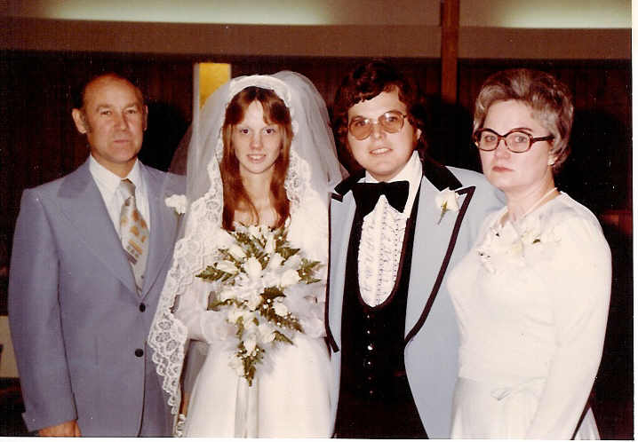
The year 1976 saw the formation of Apple by Steve Jobs and Steve Wozniak. Nadia Comaneci scored the first ever perfect score in gymnastics. South African riots marked the beginning of the end for apartheid in that country, the first space shuttle was unveiled, the US celebrated its Bicentennial, and the first cases of Legionnaires Disease were reported. The average US yearly income was sixteen thousand dollars, a new house cost over forty-three thousand dollars, a house rented for an average of $220 per month, and a gallon of gas was 59 cents. I graduated college and got married in May 1976. Both Mom and Dad attended my wedding. Neither looked happy in the wedding pictures.
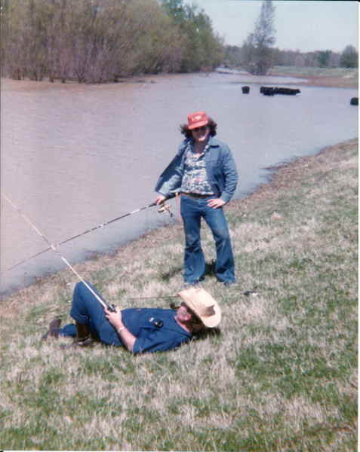
I had moved to Little Rock to work at KARK-TV toward the end of 1976 and would only be able to come up and visit Dad every now and then. On one of those occasions, Dad and I went fishing on the St. Francis River that ran behind his house. Dad continued to run the insurance agency there in Cardwell. Dad came to visit in Little Rock once. While he was visiting, his house was robbed. Dad told me that the robbery was done by Mom’s father and brother because almost everything stolen was on a list of things Mom had wanted in the divorce. I have no idea if that was true or not.
The year 1977 saw convicted murderer Gary Gilmore executed by firing squad in Utah ending a ten year moratorium on capital punishment in the US. For the only time in known history snow fell in Miami, Florida, and ten feet of snow fell in one day in upstate New York. President Carter pardoned all the American Vietnam draft evaders. It was discovered that the Planet Uranus also had rings similar to Saturn. The worst aviation disaster in history occurred in the Canary Islands when two Boeing 747 airliners collided on a foggy runway killing 583 people. Optic fiber was first used to carry live telephone traffic. Star Wars hit the theaters around the world. The four day long Libyan-Egyptian War happened as did the Ethiopian-Somali War. Elvis performed his final concert as he died later that year. The US Department of Energy was created. Riots broke out in Sri Lanka and over 300 minority Tamil people were killed. “Son of Sam” serial killer David Berkowitz is arrested. The last guillotine execution took place in France. Egyptian President Anwar Sadat became the first Arab leader to officially visit Israel.
In May of 1977, I joined the Marine Corps and was sent to boot camp in San Diego, California. No one came to my graduation from boot camp that August. I ended up stationed there at the recruit depot after boot camp and my wife and I moved there after a short leave.
The game Space Invaders was released in 1978 along with Van Halen’s first album Van Halen, and Stephen King’s The Stand was published. Coming Home, a story of an injured Vietnam War veteran’s difficulty in re-entering civilian life, along with the films Grease, National Lampoon’s Animal House, and the animated The Lord of the Rings were in American theaters. Leon Spinks won the boxing heavyweight title from Muhammad Ali only to loose it back to Ali later that same year. The first successful “test-tube” baby was born and two popes died that year. In September of 1978, Pacific Southwest Airlines Flight 182 collided with a Cessna 172 light aircraft over San Diego. The recruit depot was called on to give blood. It was shortly after that time we found out my wife was pregnant with our first child.
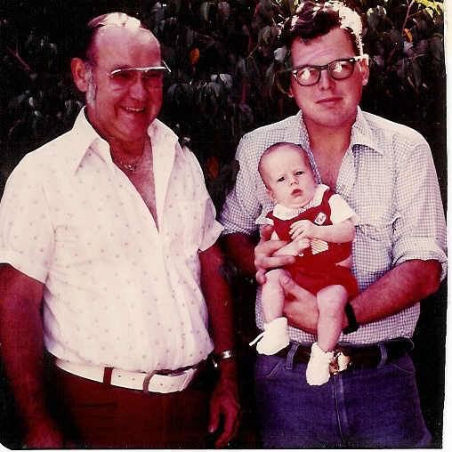
It was in 1979 that formal diplomatic relations were established between China and the US. Also, that year Vietnam invaded Cambodia. The last Iranian Shah fled Iran and relocated to Egypt. Patty Hearst was released from prison after her bank robbery sentence was commuted by President Carter. Snow fell in the Sahara Desert for the only time in recorded history. The first Compact Disk was demonstrated by Philips Corporation. C-Span began broadcasting the US House of Representatives day-to-day business. Margaret Thatcher became the first female Prime Minister of the United Kingdom. The Walkman was introduced by Sony Corporation. Saddam Hussein came to power in Iraq. CompuServe launched the first consumer Internet services. The US returned the Panama Canal to Panama. The first Gay Rights march in Washington, DC. occurred with over 200,00 people attending. Mother Teresa was awarded the Nobel Peace Prize. The President of South Korea was assassinated by the Korean Central Intelligence Agency head. The Iran Hostage situation began in November of 1979. On July 27, 1979 my wife gave birth to Dad’s first and, to my knowledge, only biological grandson. In August of 1979, Dad visited to see us and the new baby. The only other time he had visited was to see my brother. Bruce, graduate from Marine Corps boot camp.
Mount St. Helens erupted in 1980 and killed 57 people. Post-it notes hit the market and the Rubik’s Cube craze also started that year. Iran and Iraq went to war with each other. CNN began broadcasting that year. The US defeated the Soviet Union in ice hockey in the “Miracle on Ice” and then boycotted the Moscow Summer Olympics. John Lennon was killed by an obsessed fan. President Carter ordered the failed rescue attempt in April of 1980 that cost the lives of eight US. Servicemen. The average income was under $20,000, the average new house cost over sixty thousand dollars, rent averaged $300, the average new car was over $7000, and a gallon of gas was $1.19. I was transferred to the east coast that year and Dad helped bring my wife and son to Quantico, Virginia where I had been stationed. Dad voted for Ronald Reagan for president in November of 1980. He had voted for Carter in 1976 but this was about the time that many Southern Democrats switched to the Republican party.
The Iranian hostages were released after Reagan, the oldest man ever elected president, took office in 1981. In England, the “Yorkshire Ripper” was arrested. The Las Vegas Hilton hotel-casino burned killing eight people and injuring 198. Walter Cronkite retired from the CBS Evening News. On March 31, 1981, John Hinkley, Jr. attempted to assassinate then President Ronald Reagan. The first successful portable computer, the Osbourne 1, was unveiled. A US submarine collided with a Japanese cargo ship sinking it. The first space shuttle mission took off. A Navy jet crashed on the fligh deck of the aircraft carrier USS Nimitz killing 14 and injuring 45. Two thousand people die in a 6.9 magnitude earthquake in Iran. A walkway at the Hyatt Regency in Kansas City, Missouri collapsed killing 114 and injuring 200. MTV began broadcasting. President Reagan fired almost 12,000 striking air-traffic controllers who ignored his order for them to return to work. The Washington Star ceased publication. The IBM personal computer was released. American fighter jets intercepted and shot down two Libyan fighters over the Gulf of Sidra. Capital punishment was abolished in France. Egyptian President Anwar al-Sadat was assassinated. President Reagan authorized the CIA to recruit and support the Contra rebels in Nicaragua. Nine hundred civilians were massacred during an anti-guerrilla campaign in El Salvador.
On January 13, 1982, Air Florida Flight 90 crashed into the Potomac River in Washington, DC. The US government ordered the break-up of the AT&T monopoly. Seven people were killed with Tylenol capsules laced with potassium cyanide in Chicago that year. Argentina invaded the Falkland Islands and Great Britain went to war with them over the islands. A wave of terrorist attacks hit France by Carlos the Jackal. The US was hit by a major recession. Michael Jackson’s Thriller was at the top of the album charts while E.T. was debuting in theaters. The first issue of USA Today was published. The Vietnam Veterans Memorial was dedicated in Washington, DC. The average income was just over $21,000 while a new home was approaching $68,000. Gas was 91 cents a gallon while the average new car was almost $8,000. In February of 1982 I was discharged from the Marines and in March Dad became a grandfather again. My daughter, Jaclyn Katie Summitt, was born March 19, 1982. I went back to work for KARK-TV in Little Rock. That December, nine tornadoes ripped through Arkansas, five of which had an F3 rating. Fifty-three people were injured and two were killed. I got my first computer in 1982. I bought it from Bruce. It was a Radio Shack Model I with 4k of RAM and a cassette drive for program and data storage.
The year 1983 was the year the Internet was born when ARPANET officially changed to using the Internet Protocol. Sixty-four people died in a cinema fire in Turin, Italy. The United Bank of Knoxville, Tennessee collapsed due to fraud. Brush-fires in Australia killed 75. A special commission of the US Congress released a report condemning the internment of Japanese-Americans during WWII. CDs and CD players went on sale for the first time in the US. President Reagan called the Soviet Union an “evil empire.” The US Embassy in Beirut, Lebanon was attacked by a suicide bomber and 63 people were killed. The so-called Hitler Diaries are allegedly discovered in East Germany and are shortly revealed to be a hoax. The first publication of the discovery of the HIV virus that caused AIDS was reported in the Journal Science. An unlicensed fireworks plant near Benton, Tennessee exploded killing 11 people. Sally Ride became the first American woman in space. The Sri Lankan Civil War began. A Korean Ail Liner was shot down by Soviet jet fighters killing all 269 passengers including a US congressman. Vanessa Williams became the first black Miss America. The US Marine Corps barracks in Beirut is bombed killing 241 while the French barracks are also hit killing 58. Martin Luther King, Jr. Day is signed into law by President Reagan. A bomb exploded in the US Senate. Luckily, no one was injured. Windows 1.0 was introduced.
The year 1984 saw Apple Computer air their infamous, Ridley Scott directed 1984 commercial introducing the Macintosh to the world during the Super Bowl that created the Super Bowl commercial industry. Richard Branson began Virgin Airways. Prince and the Revolution released Purple Rain. The Soviet Union boycotted the 1984 Summer Olympics in retaliation for the US boycott in 1980. Geraldine Ferraro became the first woman to run on a major political party’s presidential ticket as Mondale’s VP choice. Reagan was re-elected. The game Tetris was released. The infomercial became airing. The first untethered space walk by American astronauts took place. Ghostbusters was box-office gold. Satanic panic hit America as accusations, allegations, and collective hysteria took six years to have all charges to be dropped against several teachers in California. Hong Kong, a British colony since 1842, was agreed to be returned to China. The first MTV Music Award show aired. Vanessa Williams was stripped of her Miss America crown when nude photos she’d posed for previously were published in Penthouse. Twenty-one people were killed and 19 wounded when a man walked into a McDonalds in California and began shooting. Indira Gandi was assassinated. Marvin Gaye was killed by his father when he intervened in a fight between his parents.
For better or worse, New Coke was introduced in 1985. The Unibomber killed his first victim, CDs were introduced, the Titanic was found, nine thousand people died in the Mexico City earthquake, France sank a Greenpeace ship, blood donations began to be screened for AIDS, the first dot com was registered, and as millions started in Africa, singers in the US joined together to sing “We Are The World.” A new home cost almost $90,000 while the average income was just a little over $22,000. Rent averaged $375 per month and the average new car was over $9,000. Stamps were 22 cents, a movie ticket was $2.75, and a gallon of gas was $1.09. I went through my first divorce in 1985. I went to work for the Arkansas Educational Network. During the custody battle for Michael and Jackie, I agreed to go back to school for my Master’s degree so I could be home with the kids instead of traveling doing documentaries.
I started back to school at Arkansas State University in January of 1986. Dad helped with my car payment while I borrowed money to put myself through school. I did end up with a graduate assistantship after the first semester to help cover costs. I had bought an Atari 800XL computer with 64K of memory and a 5.25 in floppy disk drive during this time and that’s what I would use to write my Master’s Thesis.
The year also saw mad cow disease hitting cattle in the United Kingdom, sweeping tax reforms in the US where social security began being taxed to cover lower taxes for the rich, Reagan’s Iran-Contra Affair became public, the US bombed Libya, and the Space Shuttle Challenger exploded in mid air shortly after take off. The Internet Mail Access Protocol opened up the way for e-mail, Chernobyl Nuclear Power station exploded becoming the worst Nuclear disaster up until that time, and Halley’s Comet visited the solar system for the second time in the 20th century. The average cost of a house was between eighty and ninety thousand dollars while the average income per year was slightly over twenty-two thousand dollars. Average monthly rent was $385.00. The price of a new car was almost $9500. The price of gas was down to 89 cents per gallon. A Tandy 600 portable computer was $1600.
The 1987 an Amtrak train on its way to Boston from Washington, DC collided with a train in Chase, Maryland, killing 16 people. In England, a ferry capsized killing 193. Jim Bakker resigned from the PTL club over a sex scandal. A car bomb ins Sri Lanka kills 106. The first heart-lung transplant takes place in Baltimore, Maryland. An Iraqi fighter jet fires two missiles on a US warship killing 37 and injuring 21. The Iraqi armed forces used chemical warfare on Iranian civilians. The FCC rescinded the Fairness Doctrine which required radio and television stations to present controversial issues “fairly.” Romanians rebelled against their communist regime. Also that year, in the worst peacetime sea disaster ever, a passenger ferry collided with an oil tanker off the Philippines sinking and killing an estimated four thousand people. I graduated from Arkansas State with a Master’s Degree in Mass Communication. I also remarried and moved to West Virginia to teach college. I bought one of those Tandy 600 portables as well as my first IBM clone during that time frame also.
In 1988, in Lebanon, a US Lieutenant Colonel serving with the United Nations is taken prisoner and tortured to death. Jimmy Swaggart confessed to an affair with a prostitute and leaves the pulpit. Walmart opened its first super-center. Oliver North and John Poindexter are indicted on charges stemming from the Iran-Contra scandal. Fighting erupted between Honduras and Nicaragua with the US sending jets to bomb Nicaraguan troops. The Soviet Union, after more than eight years in Afghanistan, began withdrawing their troops. Dukakis became the Democratic candidate for President. The Republicans chose George H. W. Bush. Bush wins with 53.4 percent of the popular phone. The Soviet Union announced to the UN that it will be withdrawing all troops from its Warsaw Treaty allies. Just before Christmas, Pan Am Flight 103 exploded over Lockerbie, Scotland killing 270.
The year 1989 opened up with two US Navy fighter jets shooting down two Libyan Mig fighters over the Gulf of Sidra. Meanwhile, the last Soviet armoured units left Afghanistan. A military coup took place in Paraguay. Union Carbide agreed to pay $470 million to the Indian government for damages caused by the 1984 Bhopal disaster. Iranian leader Khomeini issued a fatwa and offered a bounty for Muslems to Kill Salman Rushdie, author of the novel Satanic Verses. Eastern Airlines filed for bankruptcy. Pete Rose was accused of gambling on baseball and later banned from baseball. Cold fusion was discovered. Forty-seven sailors were killed when a gun turret on the USS Iowa exploded. Oliver North was convicted of three crimes and sentenced and then the convictions were overturned. China cracked down on the Tiananmen Square protests. Fifty-one people die when a pleasure boat sinks on the River Thames. The Berlin Wall was torn down. The Simpsons first episode aired. Riots broke out in Hong Kong after the government decided to forcibly repatriate Vietnames refugees. I went through my second divorce in April of 1989 and on May 13, 1989, Dad remarried at the age of 57 in Campbell, Missouri. On June 15, 1989, Dad’s older brother, William Sherrill Summitt, died in Stoddard County, Missouri. Uncle Sherrill had been about four years older than Dad. I left West Virginia and moved to Cardwell, Missouri, in July.
The year 1990 saw McDonald’s opening in Moscow, Russia. Nelson Mandela was released from prison in South Africa. Lithuania struggled against the Soviet Union for independence. Soon, Latvia and Belarus both declare independence also. The World Health Organization removed homosexuality from its list of diseases. Iraq invades Kuwait. East and West Germany reunited into a single Germany. The first page appeared on the World Wide Web. I took a teaching job in Jefferson City, Missouri.
In January of 1991, I remarried in Jefferson City, Missouri. A civil war began in the country of Georgia. The US Congress authorized the use of force to drive Iraq out of Kuwait. Soviet troops killed 14 and wounded over a thousand Lithuanian independence protesters in Viluius, Lithuania. Coalition forces go to war in Kuwait with Iraq. Iraq fires Scud missiles into Israel trying to provoke Israeli retaliation injuring over a hundred people. Thirty-four people are killed and thirty injured when two airliners colide on the runway at Los Angeles International Airport. Four hundred Iraqi civilians are killed when allied “smart bombs” hit a shelter in Baghdad allies claim was a military communications outpost. An Iraqi Scud hit American military barracks in Saudi Arabia killing 28 US Army Reservists from Pennsylvania. President Bush announced that Kuwait had been liberated and the first Gulf War was over. Latvia and Estonia voted for independence from the Soviet Union. An amateur video captured Rodney King being beaten by Los Angeles police officers. Exxon agreed to pay $1 billion for the clean-up of the Exxon Valdez oil spill in Alaska. A US Senator and others are killed when a helicopter collided with their airplane over an elementary school in Merion, Pennsylvania. A US Senator and an astronaut, along with 23 others, were killed when an airliner crashed in Brunswick, Georgia. The country of Georgia announced its independence from the Soviet Union. A cyclone struck southeastern Bangladesh with winds over 155 mph, killing 138,000 people and leaving 10 million homeless. Riots broke out in Washington, DC, after police shot a Salvadoran man. Former Indian Prime Minister Rajiv Gandhi was assassinated by a female suicide bomber in Madras. A volcano erupted in Japan killing 43 researchers and journalists. Another volcano erupted in the Philippines killing over 800 becoming the second largest volcanic eruption in the 20th Century. Soviet occupation of Hungary ended. The capital of Germany is moved back from Bonn to Berlin. Jeffrey Dahmer was arrested after human remains were found in his apartment. Tim Berners-Lee released his concept of the World Wide Web which became publicly available on the Internet. Armenia, Azerbaijan, Belarus, Estonia, Latvia, Kyrgyzstan, Moldavia, Tajikistan, Ukraine, and Uzbekistan all declared independence from the Soviet Union. Linus Torvalds released the first version of the Linux computer operating system. The Dead Sea Scrolls were finally made available to the public. Croatia declares its independence from Yugoslavia. A 6.8 magnitude earthquake in India kills more than 1000. Magic Johnson announced he was infected with HIV and retired from the NBA. A postal worker in Michigan went on a shooting spree killing four and wounding five before committing suicide. The Soviet Union is abolished. And a Missouri court sentenced a Palestinian man and his wife to death for the Honor killing of their daughter.
For those who wanted to quit smoking cigarettes, the first nicotine patch was introduced in 1992 and DNA fingerprinting was invented. The war in the former Yugoslavia expanded between Muslems, Serbs, and Croats requiring UN intervention. Rioting broke out in England. Euro Disney opened in France. Bill Clinton was elected President and the Mall of America became the largest mall in America. The average income was up to a little over $30,000 but new home was over $122,000 and rent was over $515. A new car cost almost $17,000 though a gallon of gas was still just over a dollar.
The year 1993 saw the country of Czechoslovakia divided into Slovakia and the Czech Republic. An oil tanker ran aground on one of the Shetland Islands and spilled 84,700 tons of crude oil. The Sri Lankan Civil War saw their Navy kill upwards of 100 civilians in the Jaffna Lagoon massacre. Indian troops killed 55 Kashmiri civilians in retaliation for an attack on a border security force patrol. Five people were shot, two of which died, outside the CIA headquarters in Langley, Virgina. A truck bomb exploded under the North Tower of the World Trade Center killing six and injuring over a thousand. Three hundred die and hundred are injured when bombs exploded in Mumbai, India. The first Pentium chip is shipped by Intel Corporation. The 51-day Waco Siege of the Branch Davidians ended when a fire killed eighty-one people. The Mosaic Web Browser was released and CERN announced that the World Wide Web protocols would be free. A toy factory in Thailand caught fire and 156 workers died. The great floods of the Missouri and Mississippi Rivers devastated Missouri. Israel attacked Lebanon. An airliner over the Republic of Georgia is shot down killing all aboard. Russian tanks surrounded and fired on the Russian parliament. A monument honoring the women who served in Vietnam was dedicated in Washington, DC. NAFTA was approved. The Brady Bill was signed into law by President Clinton. In 1993 my family and I moved to Pittsburg, Kansas. My Dad never visited us there.
Battles between the Mexican Army and rebellious Indians in the south of the country killed 57 people in 1994. Hundreds were killed in a prison revolt in Venezuela. A Russian jet crashed in Siberia killing 122. More than a hundred people are hospitalized and four died as homes are destroyed and more than 15,000 flee as bushfires cover New South Wales in Australia. The trial of Lorena Bobbitt took place in 1994. Quentin Tarantino’s Pulp Fiction was a massive box office hit along with The Shawshake Redemption, The Lion King, and Forrest Gump. Kurt Cobain committed suicide. Both Yahoo and Amazon opened up on the Internet that year and the first Playstation hit the consumer market. My wife and I had books that we worked on published that year.
The year 1995 saw a 7.3 magnitude earthquake hit near Kobe, Japan killing almost 6500 people. In Israel, two suicide bombers from the Gaza Strip blew themselves up killing 19 Israelis. Russia almost launches a nuclear attack after mistaking a Norwegian research rocket for a US Trident missile. President Clinton authorized a $20 million loan to Mexico to stabilize its economy. War between Peru and Ecuador ended with a UN brokered ceasefire. The state of Mississippi formally ratified the 13th Amendment to the US Constitution becoming the last state to approve the abolition of slavery. In Tokyo, a sarin gas attack kills 13 and injures 1300. Russian paramilitary troops began massacring civilians in Chechnya. The Federal Building in Oklahoma City is bombed killing 168. SerbThe Java programming language was released. Christopher Reeve was paralyzed from the neck down after falling off his horse during a riding competition. A 7.6 magnitude earthquake hit Neftegorsk, Russia killing two thousand people, half the town’s population. A department store in Seoul, South Korea collapsed killing over 500 and injuring almost 1000. In the Bosnian War the Srebrenica massacre results in the deaths of more than 8000 Bosniaks. The Korean War Veterans Memorial was dedicated in Washington, DC. WCW Monday Nitro made its debut on the TNT cable channel. In Sri Lanka, the Air Force bombs a Tamil school killing at least 34. O. J. Simpson was acquitted of the murders of his ex-wife and her friend. Quebec narrowly voted to remain a province of Canada, 50.58% to 49.42%. A budget standoff in Congress forces the shutdown of the US government. Toy Story hits the theaters. I got sick in late 1995.
The year 1996 saw a computer beat a world chess champion for the first time. It was also the year of the Nintendo. The first novel in George R. R. Martin’s series, A Game of Thrones, was published. Comedy Central’s The Daily Show premiered. Osama bin Laden declared war on the United States. Expelled from Sudan, bin Laden moved to Afghanistan after the Taliban declared it an Islamic state. In Scotland, a man opened fire on a class of 5-6 year olds, killing all but one student, fifteen children and one teacher. The average income was just over thirty-six thousand dollars while a new house averaged almost $120 thousand. Rent was over $#550, a new car was over sixteen thousand dollars, the average price of a gallon of gas was $1.22, and postage stamps were 32 cents. Because of my illness, the kids decided they wanted to go live with their mother. At the end of the summer, my wife and I bought an old Winnebago RV and moved to Boulder City, Nevada.
In 1997, Newt Gingrich, the Speaker of the US House of Representatives, became the first Speaker to be reprimanded by the House for ethics violations. Madeleine Albright became the first woman to become Secretary of State. Two Israeli CH-53 Sikskory helicopters collided in mid-air killing 73 people. The first successful cloning of a sheep was successful in Scotland. An earthquake in Iran killed 3000. Comet Hale-Bopp visits the earth. Tiger Woods became the youngest golfer to ever with the Masters Tournament. Algeria is the scene of several massacres which kill several hundred civilians. Paula Jones is allowed to pursue her sexual harassment lawsuit against President Clinton while he was still in office. In New Jersey, a girl gave birth in a bathroom stall, put the baby in a trashcan to die, and returned to her high school prom. Diana, Princess of Wales, died in a car crash in Paris. My wife and I moved back to Cardwell, Missouri during the summer.
The year 1998 saw more massacres in Algeria and 19 European countries forbid human cloning. The year also saw the Monica Lewinsky-Bill Clinton scandal discovered. A bomb went off at an abortion clinic in Alabama and five clinics in Florida were attacked. The first female African-American female was appointed to rear admiral, for the first time in 14 years a woman was executed in Texas, and a US military pilot caused the deaths of 20 people in Italy when his plane cut the cable of a cable-car. Titanic became the first film to gross over one billion dollars worldwide. The Jonesboro Westside Shootings took place in March of 1998. I was the television news producer for the 6PM news at KAIT-TV during that time. Five thousand people were killed when a 6.6 magnitude earthquake hit Afghanistan. Child abuse by Roman Catholic priests first hit the news. US embassies around the world were bombed. The Google Internet search engine was created. President Clinton became the 2nd US president to be impeached.
The world’s population in 1999 surpassed six billion people. The war in the Balkans continued as did fighting between Pakistan and India over Kashmir. Everyone worried about the millennium bug that was expected to cause trouble to business and infrastructure. Earthquakes in Turkey killed over 14 thousand people. Napster was created and SpongeBob premiered. Bill Clinton was acquitted by the US Senate. While the average yearly income was a little over $40 thousand, a new home averaged almost $132 thousand and monthly rent was $645. Gasoline was $1.22 a gallon and a new care was over $21 thousand. Stamps were 33 cents each. By July of 1999, I had moved to Columbia, Missouri and was doing Web development.
Technology didn’t fail on January 1, 2000, but the last original weekday “Peanuts” comic strip was published on the third and Charles M. Schultz died in February. Russian forces massacred at least 60 civilians in Chechnya as war erupted in the country. Almost a thousand members of a Ugandan cult died either by murder or suicide at the direction of the cult leaders. Microsoft was found guilty of violating antitrust laws. Putin became president of Russia. Israel withdrew its forces from southern Lebanon after 22 years of occupation. A Russian submarine exploded and sank in the Barents Sea. The USS Cole was damaged by two suicide bombers killing 17 crew members and wounding at least 39. The first crew took residence in the International Space Station which has been crewed continuously since. The election of 2000 was extremely controversial and had to be decided by the Supreme Court in Bush’s favor despite Gore having won the popular election. One hundred fifty-five skiers and snowboarders died in a cable car fire in Austria. Retail Giant Montgomery Ward announced it was going out of business after 128 years. The election of 2000 saw me working for various political campaign Web sites. Dad was firmly entrenched as a Republican by this time and was getting all of his information from Fox News. This led to many arguments and more than once he asked me who had brain washed me. I kinda thought like that was the pot calling the kettle black.
I went to work in Jefferson City in 2001 as a technical service provider for a retirement fund. I attended the big Summitt family Reunion in North Carolina that year. Dad wasn’t able to go. Dad was now getting all his information about the world now from Fox. The year 2001 saw Timothy McVeigh executed. President Bush refused to sign the Kyoto Agreement on Climate Change. The US pulled out of the 1972 Ballistic Missile Treaty. Then, in September, nineteen hijackers took control of four domestic commercial airliners crashing two into the World Trade Center in New York, a third into the Pentagon outside of Washington DC, and the fourth crashing in a field in Pennsylvania. The US invaded Afghanistan immediately afterward to get rid of the Taliban and find Osama bin Laden. California suffered rolling blackouts and rate hikes of up to 46 percent and then Pacific Gas and Electric filed for Chapter 11 Bankruptcy protection. Enron also filed for Chapter 11 Bankruptcy protection. Cincinnati’s mayor declared a state of emergency after three nights of riots. The average yearly income was over $42 thousand while the average new house cost over $136 thousand. A new car was almost $26 thousand and a gallon of gas was $1.36. Postage was up to 34 cents for a letter.
I didn’t visit as often as I should have those last few years. I was able to videotape him explaining some of the family history pictures he had hanging in his house, some of which I did manage to get after his death. My brother and I also were able to play guitar and sing with him on a couple of occasions and those were recorded also. I’ve placed audio recordings of Dad’s band on SoundCloud and videos of us playing and singing together on YouTube.
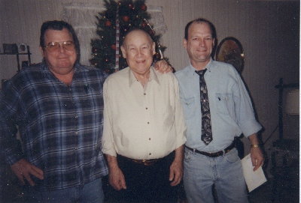Photograph 11: 2004: Paul Moody Summitt, Chester Moody Summitt, and Bruce Allen Summitt
The year 2002 saw Kmart file for Chapter 11 bankruptcy protection. An armory in Nigeria exploded killing 1100 people. President Bush named Iraq, Iran, and North Korea as the “Axis of Evil.” Fifty nine Hindu pilgrims were killed when a Muslim mob torched a train in Godhra, India. Another 97 were killed in the Naroda Patiya massacre and another 69 in the Gulbarg Society massacre in India. The US invaded Afghanistan. Twenty-nine people are killed in Israel by a suicide bomber during the Passover Massacre. In France, a gunman opened fire at the end of a town council meeting killing 8 and injuring 19. A synagogue is bombed in Tunisia killing 21. In Germany, a man kills 16 in a gymnasium before killing himself. A jury in Alabama convicted a former Ku Klux Klan member of the 1963 deaths of four girls in the 16th Street Baptist Church bombing. A Chinese Airliner disintegrated in mid-air killing all225 aboard. South and North Korea battled at sea leading to the deaths of six South Korean sailors and the sinking of a North Korean vessel. A Russian transport helicopter was hit by a Chechen missile killing 118 Russian troops. A possible meteorite impacted in Siberia. A ferry off the coast of Gambia sank killing over 1000. The Beltway Sniper attacks occurred with two individuals being arrested after three weeks. In Bali, terrorists set off bombs which killed 202 and injured over 300. In Moscow, Chechen terrorists seize a theater with over 700 hostages. Fifty Chechen terrorists and 150 hostages died when the Russian military stormed the theater. In Vietnam, a department store was destroyed by fire killing over 60 and over 100 were unaccounted for. In Nigeria, the Miss World contest was attacked and over 100 people were killed.
In 2003 the Space Shuttle Columbia disintegrated on re-entry. A 7.6 magnitude earthquake in Mexico left ten thousand people homeless. The US invaded Iraq. A fire in a subway in South Korea killed over 200 hundred people. An Iranian military aircraft crashed in Iran killing 275. A fire broke out during the pyrotechnics display at a Great White concert in Rhode Island killing 100 and injuring over 200 more. Nature publishes that 350,000-year-old footprints of an upright walking human were found in Italy. President Bush declared the war in Iraq over. Thirty-three were killed and more than a hundred injured in the 2003 Casablanca bombings. More than 2000 died in an earthquake in northern Algeria. The Wikipedia Foundation was founded. Netscape was disbanded and the Mozilla Foundation was established. Widespread electrical outages occurred in the northeast US and Canada. Twenty-one are killed and fifty-one injured in the suicide bombings of a restaurant in Israel. Mother Teresa was beatified by Pope John Paul II. The Concorde made its final flight. Former Iraqi President Saddam Hussein was captured. A 6.6 magnitude earthquake in southeast Iran kills tens of thousands.
In 2004 an Egyptian airliner crashed into the Red Sea killing 148 people. The NASA Mars rover successfully landed on Mars. During a pilgrimage in Saudi Arabia, 251 people were trampled to death and 244 were injured. The mayor of San Francisco directed the issuance of marriage licenses to same sex couples. In Iran, almost three hundred people, nearly 200 of which were rescue workers, when a freight train carrying sulfur, petrol, and fertilizer caught fire and exploded. Al-Qaeda kills 170 people and wounds over 500 in the Ashoura Massacre in Iraq. Explosions on rush hour trains in Madrid kills almost 200 people. Twenty-two people are killed and over 200 wounded in religious unrest in Kosovo. Ireland became the first country in the world to ban smoking in all work places, bars, and restaurants. Gmail went public. Seventy-four people were killed and 160 wounded in five suicide car bombings in Basra. Two fuel trains collied in North Korea killing around 150 people. Armed Muslems killed over 78 Christians in Yelwa resulting in over 630 Muslims then being killed by Christians. Pictures showing American soldiers abusing and sexually humiliating Iraqi prisoners at Abu Ghraib prison were released. The first legal same-sex marriages were performed in Massachusetts. Terry Nichols was found guilty of murder in connection with the Oklahoma City bombing. Capital punishment was declared unconstitutional in the state of New York. A supermarket fire in Paraguay killed 396 and injured 500. One hundred fifty-six Tutsi refugees were massacred at a refugee camp in Burundi. Female suicide bombers destroy two Russian aircraft killing 89 people on board. Hurricane Jeannie hit Haiti killing over 1000 people. Thirty-five people were killed, 2200 were injured, and over 85000 were left homeless when a powerful earthquake and its aftershocks hit northern Japan. An earthquake in the Indian Ocean and the tsunami created by the 9.3 magnitude earthquake devastated Sri Lanka, India, Thailand, Malaysia, the Maldives, and many other areas around the rim of the Indian Ocean killing over 230,000 people. One hundred ninety-four people were killed in a nightclub fire in Buenos Aires, Argentina. I went to India during 2004 before the earthquake to attend the wedding of a young man that worked for me. I was there twenty days. My daughter, Jackie, gave birth to twin boys, Ashton and Aydon, in May of 2004 making Dad a great-grandfather for the first time.
A stampede at a Hindu temple in India killed over 255 people in early 2005. YouTube was launched on the Internet. A suicide bomber in Iraq killed 127. The execution of juveniles found guilty of murder in the US was found unconstitutional by the Supreme Court. An oil refinery in Texas City exploded killing 15 workers. The Oregon Supreme Court nullified marriage licenses issued to gay couples the previous year. A train crash in Japan killed over a hundred people. An attempted assassination of President Bush fails in Georgia. Michael Jackson was acquitted of molesting a 13 year old boy. After almost forty inches of rain fell in 24 hours, over 5000 people are killed in the floods around Mumbai, India. Hurricane Katrina killed almost 2000 people along the Gulf Coast. Almost 1200 people died in the Al-Aaimmah Bridge stampede in Baghdad. The last episode of Tom and Jerry aired. A 7.6 magnitude earthquake killed thousands of people in Pakistan, India, and Afghanistan. Hurricane Wilma killed over 60 people in Florida. More than 60 people are killed in bombings in Delhi. At least 60 were killed by suicide bombers in Jordan. An Iranian military transport crashed into a apartment building in Tehran killing all 84 on board and 44 on the ground. Chad declared war on Sudan after over 100 people are killed in the Battle of Adre’. My son, Michael, became a father for the first time on his birthday on July 27, 2005, giving Dad his first great-granddaughter, Alana. I visited Germany and France before I became ill that later that year and was forced to retire.
The year 2006 started with a coal mine disaster in West Virginia that killed 12 miners. In Saudi Arabia at the Stoning of the Devil ritual over 360 Muslim pilgrims were killed 70 during a stampede. A Mexican professional wrestler was arrested in connection with the serial killing of at least ten elderly women. The roof of one of the buildings at the Katowice International Fair in Poland collapsed due to the weight of snow and killed 65 while injuring over 170. A stampede at a sports arena near Manila in the Philippines killed 71. The last MASH unit was decommissioned by the US Army. A methane explosion in a coal mine in Mexico killed 65 miners. Over 150 Chadian soldiers were killed by rebels during an attempt to kill the president of Chad. In April, over 60 tornadoes hit the central US with Tennessee having 29 people killed. A suicide bomber in Tel Aviv killed 11 and injured. Over 150 people were killed during violence in Sao Paulo, Brazil. In Java, over 6600 people were killed when Yogyakarta was devastated. Two hundred nine people were killed in a series of bomb attacks on trains in Mumbai, India. Fidel Castro handed power in Cuba over to his brother Raul. Sri Lankan government forces killed 17 employees of the French organization INGOn Action Against Hunger. Sixty-one Tamil girls were killed in a Sri Lankan Air Force bombing in Chencholai. The planet Pluto was reduced to a dwarf planet by the International Astronomical Union. One student was killed and 19 others injured in the Dawson College shooting. A small airliner crashed in Lexington, Kentucky killing 49 of the 50 on board. A mid-air collision between two jets killed 154 people over Brazil. Al Jazeer English goes on the air. Bombings in Sadr City, Iraq kill at least 215 and injure at least 257. In Malaysia, floods began that in the end would kill at least 118 and displace over 400,000. An Indonesian ferry sank killing at least 400 and former President of Iraq Saddam Hussein was executed.
In 2007 the first iPhone was unveiled. Car bombs exploded in Baghdad killing at least 88 in January and another 135 killed and 339 injured in February. Bombs in India killed 68. Bombs in the capital of Algiers killed 33 and injured 222. A gunman at Virginia Tech killed 32 and injured 17 before committing suicide. April saw more bombs in Baghdad with 198 killed and 251 injured. Over 50 people were killed and over 100 injured during riots in Karachi, Pakistan. Smoking was banned in all indoor public spaces in England. An airliner missed the end of the runway at the airport in Sao Paulo, Brazil killing 199 people. Peru was hit by an 8.0 magnitude earthquake killing over 500 and injuring over 1000. Blackwater mercenaries shot and killed 17 Iraqis in Baghdad but all charges against them were dismissed. An attack on the Prime Minister of Pakistan in Karachi killed 139 and injured over 450 more but missed the prime minister. A bomb explosion in a shopping mall in the Philippines killed 11 and injured more than 100. The Android operating system was first unveiled by Google. A school shooting in Finland resulted in nine people killed. A gunman opened up with a semi-automatic rifle in a mall in Omaha, Nebraska killing 8 before committing suicide. The former Pakistani prime minister was assassinated.
The southern US suffered a tornado outbreak that became known as Super Tuesday in 2008 with 57 killed. A gunman opened fire on the Northern Illinois University campus causing 21 injuries and six dying, including the gunman. Eight died in Jerusalem in the Mercaz HaRav massacre and 68 died in a suicide bombing in Baghdad. A cyclone hit Burma, killing over 138,000 people and leaving millions of people homeless. A tornado hit the Oklahoma-Kansas state line killing 21 and injuring over 100. A 8.0 earthquake in Sichuan, China killed over 69,000 people. More bombings in India resulted in more deaths including blasts in Delhi that killed 30 and injured 130. . Flooding in South China caused 148 deaths and the forced evacuation of 1.3 million people. Over 300,000 Chinese infants were fed tainted milk in the Gansu Province. In the worst single mountaineering accident in history, eleven mountaineers died on K2, the second highest mountain on earth. The Russo-Georgian War began. A Spanish airliner crashed in at the Madrid airport resulting in 154 deaths. The Large Hadron Collider was powered up in Switzerland. A train wreck in Los Angeles resulted in 25 people killed. Fifty-four people were killed and 266 injured when a dump truck full of explosives detonated in front of the Marriott Hotel in Islamabad, Pakistan. Barack Obama became the first man of African-American descent to be elected President of the United States. The Veteran’s Administration and Social Security Administration disabled me in 2008.
The year 2009 began with 69 people dying in a nightclub fire in Bangkok, Thailand. The governor of Illinois was removed from office after being convicted on corruption charges. A supermarket fire in Nairobi, Kenya killed at least 25. In Molo, Kenya, an oil spillage ignited resulting in 113 deaths and over 200 injured. In Germany, a recent graduate killed 16 and injured 11 before killing himself. A dam in Indonesia failed resulting in the deaths of at least 99 people. Forty-eight people were killed in a suicide bombing at a mosque in Pakistan. Dad had a heart attack at home in Cardwell, Missouri, while taking a shower on April 27, 2009. He was pronounced dead at the hospital in Paragould, Arkansas. He was 77 years old.
That last year of his life, Dad and I talked on the phone almost every week. I remember telling him each week I would try to go down and visit soon. The six hour drive from Columbia to Cardwell was getting harder for me to do and I kept putting it off. Dad is buried in the Cardwell Cemetery in Cardwell.
Dad, as all of us, was a product of his environment, of the events that took place around him, and of the people he associated with. I didn’t agree with him very often in those last years as he became more and more right-wing in his thinking and less accepting of others who were different. It’s unfortunate because overall I believe he was a good man but he was easily swayed by those he wanted to like him.

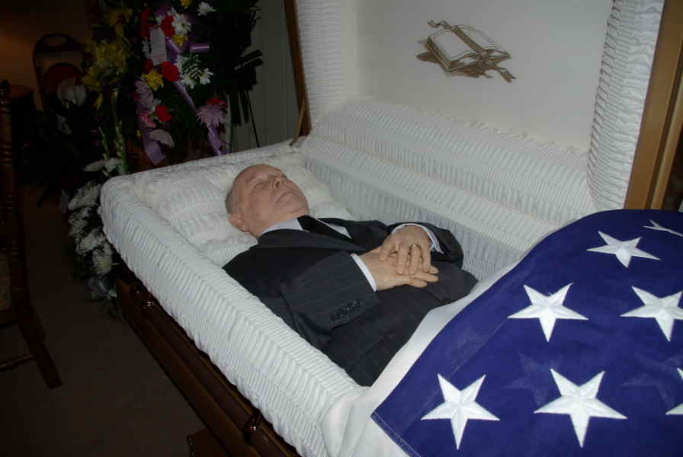
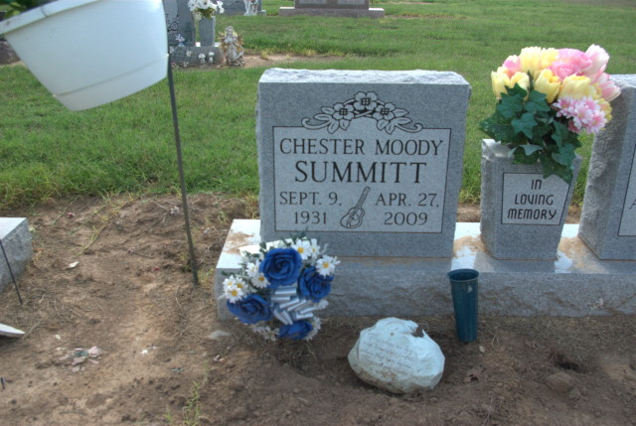

SUMMITT, Chester Moody
b. 1931-09-09
d. 2009-04-27
m. 28May1976
FRIE, Shirley Francis
b. 13 October 1934
d. 5 August 2012
m. 1950-09-14
SUMMITT, Paul Moody
b. 07Apr1954
Summitt, Bruce Allen
b. 31Dec1959

Social Security Death Index, Number 491-36-0355; Issue State: Missouri; Issue Date, 1951: United States Obituary Collection: Newspaper: Daily Dunklin Democrat; Publication Date: 30 Apr 2009; Publication Place: Kennett, MO, USA.: U.S. Department of Veterans Affairs BIRLS Death File, 1850-2010:1940 United States Federal Census.
http://www.thepeoplehistory.com/1931.html
https://worldhistoryproject.org/1932
http://www.eventshistory.com/date/1933/
http://www.fsmitha.com/time/1934.htm
http://www.fsmitha.com/time/1935.htm
Web: Missouri, Death Certificates, 1910-1962
http://www.fsmitha.com/time/1936.htm
http://www.fsmitha.com/time/1937.htm
http://www.eventshistory.com/date/1938/
http://www.eventshistory.com/date/1939/
Online publication - Provo, UT, USA: Ancestry.com Operations, Inc., 2012.Original data - United States of America, Bureau of the Census. Sixteenth Census of the United States, 1940. Washington, D.C.: National Archives and Records Administration, 1940. T627
https://americasbesthistory.com/abhtimeline1940.html
http://www.thepeoplehistory.com/1941.html
http://www.fsmitha.com/time/1942.htm
http://www.eventshistory.com/date/1943/
http://www.thepeoplehistory.com/1944.html
http://www.eventshistory.com/date/1945/
http://www.thepeoplehistory.com/1946.html
http://www.thepeoplehistory.com/1947.html
http://www.eventshistory.com/date/1948/
https://sechistorical.org
Online publication - Provo, UT, USA: Ancestry.com Operations, Inc., 2011.Original data - "Arkansas County Marriages, 1838–1957." Index. FamilySearch, Salt Lake City, Utah, 2009, 2011. "Arkansas County Marriages, 1838–1957," database, FamilySearch; from Ark
http://www.eventshistory.com/date/1951/
Online publication - Provo, UT, USA: Ancestry.com Operations, Inc., 2011.Original data - Beneficiary Identification Records Locator Subsystem (BIRLS) Death File. Washington, D.C.: U.S. Department of Veterans Affairs.Original data: Beneficiary Identificatio
http://www.fsmitha.com/time/1952.htm
http://www.fsmitha.com/time/1953.htm
Tennessee State Library and Archives; Nashville, Tennessee; Tennessee Death Records, 1908-1959
http://www.eventshistory.com/date/1954/
http://www.eventshistory.com/date/1957/
http://www.thepeoplehistory.com/1958.html
http://www.eventshistory.com/date/1959/
http://www.thepeoplehistory.com/1960.html
http://www.eventshistory.com/date/1961/
http://www.eventshistory.com/date/1962/
https://worldhistoryproject.org/1963/page/3
http://www.eventshistory.com/date/1964/
https://www.hisdates.com/years/1965-historical-events_16.html
http://www.eventshistory.com/date/1966/
http://www.thepeoplehistory.com/1967.html
https://www.history.com/topics/1960s/1968-events
https://www.naylor.com/associationadviser/50-things-that-shaped-our-world-in-1969/
http://www.eventshistory.com/date/1970/
http://www.eventshistory.com/date/1971/
http://www.eventshistory.com/date/1972/
http://www.thepeoplehistory.com/1973.html
http://www.eventshistory.com/date/1974/
http://www.thepeoplehistory.com/1975.html
https://www.history.com/topics/crime/history-of-marijuana
https://www.pbs.org/wgbh/pages/frontline/shows/dope/etc/cron.html
http://www.thepeoplehistory.com/1976.html
http://www.eventshistory.com/date/1977/
https://worldhistoryproject.org/1978/page/5
http://www.eventshistory.com/date/1979/
http://www.thepeoplehistory.com/1980.html
http://www.eventshistory.com/date/1981/
http://www.thepeoplehistory.com/1982.html
https://www.tornadotalk.com/bryant-west-little-rock-crystal-hill-ar-f3-tornado-december-2-1982/
http://www.eventshistory.com/date/1983/
https://bestlifeonline.com/1984-events/
http://www.thepeoplehistory.com/1985.html
http://www.thepeoplehistory.com/1986.html
http://www.eventshistory.com/date/1987/
https://www.thoughtco.com/1980s-timeline-1779955
http://www.eventshistory.com/date/1989/
http://www.fsmitha.com/time/1990.html
http://www.eventshistory.com/date/1991/
http://www.thepeoplehistory.com/1992.html
http://www.eventshistory.com/date/1993/
https://www.hisdates.com/years/1994-historical-events.html
https://www.nme.com/photos/25-moments-that-defined-1994-1422189
http://www.eventshistory.com/date/1995/
https://takemeback.to/year/1996
http://www.thepeoplehistory.com/1996.html
http://www.eventshistory.com/date/1997/
http://www.eventshistory.com/date/1998/
http://www.thepeoplehistory.com/1999.html
http://www.eventshistory.com/date/2000/
http://www.thepeoplehistory.com/2001.html
http://www.eventshistory.com/date/2002/
http://www.eventshistory.com/date/2003/
http://www.eventshistory.com/date/2004/
http://www.eventshistory.com/date/2005/
http://www.eventshistory.com/date/2006/
http://www.eventshistory.com/date/2007/
http://www.eventshistory.com/date/2008/
http://www.eventshistory.com/date/2009/

